1. $ env

This will print all the variables that are associated with the current bash environment.

1. If we want to read individual variables we can use.

$ echo ${ SHELL}

This will just print out the Shell variable for the environment.

1. There are numerous variables that can be accused using this command.
2. Command: ps

ps will list all the processes.

1. Debugging

If we use bash -n script.sh

This will read all the commands in the script but it won't execute them.

This is great way to check if there is any syntax error in the code

Running bash -x script.sh executes the script script.sh in debug mode. This means that each command in the script is printed to the terminal before it's executed. It's helpful for debugging scripts to understand how they're executing and to identify any errors or unexpected behavior.

1. Bin bash script

#!/bin/bash

Mkdir directory

Touch directory/my file

Ls -l my directory

The output of this script should be the files within the folder with their permissions.

1. Variable

#!/bin/bash

$Book =”Black hat bash”

$Echo “This book is called $Book”

We can also assign an output of a command to a variable.

$ root_directory =”$(ls -ld /)”

$ echo “$root_directory”

1. Unassiging variables

We can use the command

Book = “black hat bash”

Unset Book

Echo. “$Book”

This will unassign the variables for the code.

This will not print any output in the terminal.

#!/bin/bash

PUBLISHER="No Starch Press"

print_name(){

local name

name="Black Hat Bash"

echo "$name by $PUBLISHER"

}

print_name

echo "The variable $name will not be printed because it is a local variable."

You can perform these arithmetic operations in bash in a few ways: using the let command, using the double parentheses syntax

$((expression)), and using the expr command.

Let’s consider an example of each method.

Here we perform a multiplication operation using the let

command:

$ let result="4 * 5"

$ echo $result

This command takes a variable name, then performs an

arithmetic calculation to resolve its value. Next,we perform another multiplication operation using the double parentheses syntax:

$ result=$((5 * 5))

$ echo $result

In this case, we perform the calculation within double parentheses. Lastly, we perform an addition operation using the expr command:

$ result=$(expr 5 + 505)

$ echo $result

The expr command evaluates expressions, which don’t have to be arithmetic operations; for example, you might use it to calculate the length of some string. Use man expr to learn more about the capabilities of expr.

1. HOW TO CREATE AN ARRAY IN BASH

#!/bin/bash

# Set an array

IP_ADDRESSES=(192.168.1.1 192.168.1.2 192.168.1.3)

# Print all elements in the array

echo "${IP_ADDRESSES[*]}"

# Print only the first element in the array

echo "${IP_ADDRESSES[0]}”

In order to change the permission on the file we will

$ chmod u+x arrays.sh

$ ./arrays.sh

The output will be :

192.168.1.1 192.168.1.2 192.168.1.3

192.168.1.1

We can also delete an entry from an array

IP_ADDRESSES=(192.168.1.1 192.168.1.2 192.168.1.3)

unset IP_ADDRESSES[1]

You can even swap one of the values with another value. The Following code will replace 192.168.1.1 with 192.168.1.10:

IP_ADDRESSES[0]="192.168.1.10”

**THINGS TO NOTE:**

1. To check which shell we are running zsh , dash , sh or bash.

Echo $SHELL

Or echo $0

1. In order to check all the shells we have available we can use

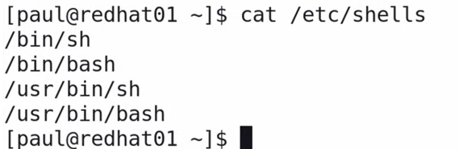

This can be used to check which all shells we have in our system.

1. In order to change to a different shell we can use

Sudo chsh

Enter the password for the user

Then type in /bin/bash

After this we will have to log out of the system (windows or linux) and then log back in to run echo$SHELL command. This would have changed our shell to the /bin/bash

1. After echo give a space

name=”This is great”

Echo “print $name , where name is a variable that has been assigned before”

1. ARRAY when creating an array we don't have to give space in between

array=(This is great practive 1 uiso lslfdp pspd)

Each time we provide a space we are basically making another entry in the array.

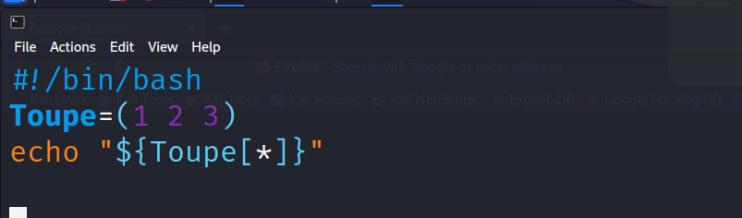

1. STREAMS

STREAMS are files that act as communication channels between a programme and it's environment.

There are 3 standards streams for a terminal

1. Standard input (stdin) : Data coming into the program as input. Usually this data is represented with number 0.

When the script is built to receive an input it is categorized as stdin.

1. Standard output (stdout) : Data coming out of the program. Usually this data is represented with number 1.

All the output that we get when we run the script / commands is generally stdout.

1. Standard error (stderr) : Error coming out of a programm. Represented with number 2.

All the syntax errors or bugs are all categoried under stderr.

1. Control Operators

Control operators in bash are tokens that perform a control function.

Table 1-5 gives an overview of control operators.

**Operator Description**

**& Sends a command to the background.**

#!/bin/bash

# This script will send the sleep command to the background

echo "Sleeping for 10 seconds..."

sleep 10 &

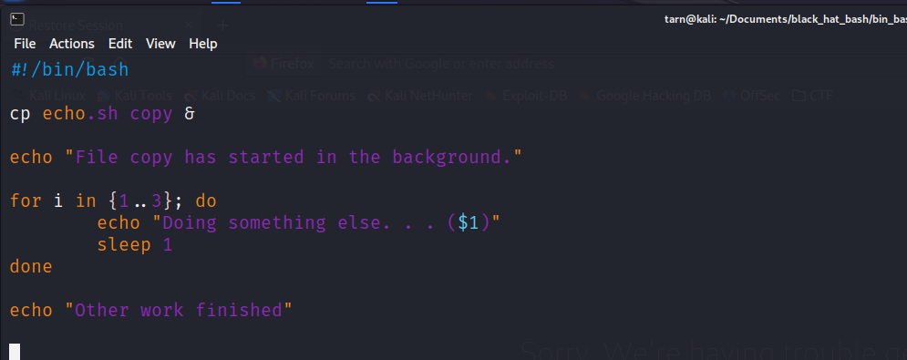

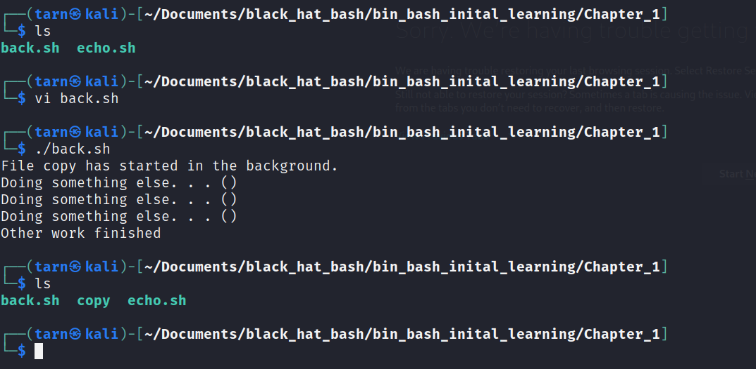

**&& Used as a logical AND. The second command in the expression will be evaluated only if the first command evaluated to true.**

touch test && touch test123

**( and ) Used for command grouping**

The () operator allows us to group commands together so they

act a single unit when we need to redirect them together:

(ls; ps)

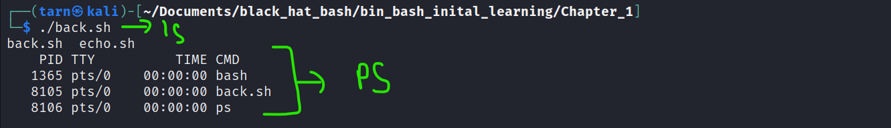

**; Used as a list terminator. A command following the terminator will run after the preceding command has finished, regardless of whether it evaluates to true or not.**

The ; operator allows us to run multiple commands irrespective

of their exit status:

ls; ps; whoami

**;; Ends a case statement.**

**| Redirects the output of a command as input to another command.**

**|| Used as a logical OR. The second command will run if the first one evaluates to false.**

The || operator allows us to chain commands together using an

OR operator:

lzl || echo "the lzl command failed"

In this example, the echo command will be executed only if the

first command fails.

1. Redirection Operators

The three standard streams we highlighted earlier can be redirected from one program to another. Redirection is taking some output from one command or script and using it as the input to another.

Table 1-6 describes the available redirection operators

Operator. Description

**> Redirects stdout to a file**

$ echo "Hello World!" > output.txt

$ cat output.txt

Hello World!

**>> Redirects stdout to a file by appending it to the existing content**

$ echo "Goodbye!" >> output.txt

$ cat output.txt

Hello World!

Goodbye!

If we used > instead of >>, the content of output.txt would have

been overwritten completely with the Goodbye! text.

**&> or >& Redirects stdout and stderr to a file**

You can redirect both the standard output stream and the

standard error stream to a file using &>. This is useful when you

don’t want to send any output to the screen and instead save

everything in a log file (perhaps for later analysis).

ls -l / &> stdout_and_stderr.txt

**To append both the standard output and standard error streams to a file, simply use double chevron (&>>).**

What if we wanted to send the standard output stream to one file, and the standard error stream to another?

This is also possible using the streams’ file descriptor numbers:

$ ls -l / 1> stdout.txt 2> stderr.txt

You may sometimes find it useful to redirect the standard error stream to a file, as we’ve done here, so you can log any errors that

occur during runtime.

For example, the next example runs a non-

existent command lzl. This should generate bash errors that will be

written into the error.txt file.

$ lzl 2> error.txt

$ cat error.txt

Note : See how the error was not outputted by the program because it was written to the error.txt file.

**&>> Redirects stdout and stderr to a file by appending it to the existing content**

**< Redirects input to a command**

supply the contents of output.txt as input to

the cat command:

$ cat < output.txt

Hello World!

Goodbye!

**<< Called a here document or heredoc, redirects multiple input lines to a com-**

**mand**

$ cat << EOF

Black Hat Bash

by No Starch Press

EOF

Black Hat Bash

by No Starch Press

**| Redirects output of a command as input to another command**

The pipe operator (|) redirects the output of one command and uses it as the input of another. For example, we could run the ls command on the root directory and then use another command to

extract some data from it, as shown here:

$ ls -l / | grep "bin”

1. POSITIONAL ARGUMENT

POSITIONAL arguments are the ones that can take arguments from user and change the output behavior.

For example if we create a script that takes IP address as a positional argument instead of changing the script for each IP address.Each time a different IP ADDRESS is provided to the script it's output behavior changes.

A bash script can access arguments passed to it on the command line using the variables $1, $2, and so on. The number represents the order in which the argument was entered. To illustrate this, the following script takes in an argument (an IP address or domain name) and performs a ping test against it using the ping utility.

Save this file as ping_with_arguments.sh:

**#!/bin/bash**

**# This script will ping any address provided as an argument.**

**SCRIPT_NAME="${0}"**

**TARGET="${1}"**

**echo "Running the script ${SCRIPT_NAME}..."**

**echo "Pinging the target: ${TARGET}..."**

**ping "${TARGET}”**

This script assigns the first positional argument to the variable TARGET. Notice, also, that the argument ${0} is assigned to the SCRIPT_NAME variable. This argument contains the script’sname

(in this case, ping_with_arguments.sh). To run this script, use the following commands:

**$ chmod u+x ping_with_arguments.sh**

**$./ping_with_arguments.sh nostarch.com**

Output

Running the script ping_with_arguments.sh...

Pinging the target nostarch.com...

PING nostarch.com (104.20.120.46) 56(84) bytes of data.

64 bytes from 104.20.120.46 (104.20.120.46): icmp_seq=1 ttl=57 time=6.89 ms

64 bytes from 104.20.120.46 (104.20.120.46): icmp_seq=2 ttl=57 time=4.16 ms

Listing 1-18 Passing arguments to a script

This script will perform a ping command against the domain nostarch.com passed to it on the command line. The value was assigned to the $1 variable; if we passed another argument, it would get assigned to the second variable, $2.

What if you wanted to access all arguments? You can do so using the variable $@. Also, using $#, you can get the total number of arguments passed. The following script demonstrates how this works:

**#!/bin/bash**

**echo "The arguments are: $@"**

**echo "The total number of arguments are: $#"**

Save this script to a file named show_args.sh and run it as follows:

**$ chmod u+x show_args.sh**

**$ ./show_args.sh "hello" "world"**

Output will be :

The arguments are: hello world

The total number of arguments are: 2

**Variable. Description**

**$0 The name of the script file**

**$1, $2, $3, […] Positional arguments**

**$#. The number of passed positional arguments**

**$* All positional arguments**

**$@ All positional arguments, where each argument is individually quoted**

When a script makes use of "$*" with the quotesbincluded, bash will expand arguments into a single word. For instance, the following groups the arguments into one word:

**$ script.sh "1" "2" "3"**

1 2 3

When a script makes use of "$@" (again including the quotes), it will expand arguments into separate words:

**$ script.sh "1" "2" "3"**

1

2

3

In most cases, you will want to use "$@" so that every argument is treated as an individual word.

**echo "Please enter your name:"**

**read name**

**echo "Hello, $name! Welcome.”**

Book script ‘

**#!/bin/bash**

**# Takes input from the user and assigns it to variables.**

**echo "What is your first name?"**

**read -r firstname**

**echo "What is your last name?"**

**read -r lastname**

**echo "Your first name is ${firstname} and your last name is ${lastname}”**

**$ chmod u+x input_prompting.sh**

**$./input_prompting**

Output

What is your first name?

John

What is your last name?

Doe

Your first name is John and your last name is Doe

Exit Status Codes

Bash commands return status codes, which indicate whether the execution of the command succeeded. Status codes fall in the 0–255 range, where 0 means success, 1 means failure, 126 means that the command was found but is not executable, and 127 means the command was not found. The meaning of any other number depends on the specific command being used and the logic it uses.

Checking Status Codes

To see status codes in action, save the following script to a file named exit_codes.sh and run it.

#!/bin/bash

# Experimenting with status codes

ls -l > /dev/null

echo "The status code of the ls command was: $?"

lzl 2> /dev/null

echo "The status code of the non-existing lzl command was: $?"

We use the special variable $? with the echo command to return the status codes of the executed commands ls and lzl. We also redirect their standard output and standard error streams to the file /dev/null, a special device file that discards any data sent to it. When you want to silence commands, you can redirect their output

to it.

You should see output like the following:

$ ./exit_codes.sh

The status code of the ls command was: 0

The status code of the non-existing lzl command was: 127

As you can see, we received two distinct status codes, one for each command. The first command returned 0 (success), and the second returned 127 (command not found).

1. Setting a Script’s Exit Codes

You can set the exit code of a script using the exit command, as shown below:

#!/bin/bash

# Sets the exit code of the script to be 223

echo "Exiting with status code: 223"

exit 223

Save this script as set_status_code.sh and run it on the command line, then use the special variable $? to see the status code it returns:

$ chmod u+x set_status_code.sh

$ ./set_status_code.sh

Exiting with status code: 223

echo $?

223

You can use the $? variable to check the exit status of a script, but also of individual commands:

$ ps -ef

$ echo $?

Exit codes are important when you have a series of scripts that call one another. You may have a workflow where one script invokes another depending on a state of a specific condition.

**Exercise 1: Recording Your Name and the Date**

To practice what you’ve learned in this chapter, we encourage

you to write a script that does the following:

1. Accepts two arguments on the command line and assigns them to

variables. The first argument should be your first name and the

second should be your last name.

2. Creates a new file named output.txt.

3. Writes the current date to output.txt using the date command.

(Bonus points if you can make the date command print the date

in the DD-MM-YYYY format; use man date to learn how this

works.)

4. Writes your full name to output.txt.

5. Makes a backup copy of output.txt, named backup.txt, using the

cp command. (Use man cp if you aren’t sure of the command’s

syntax.)

6. Prints the content of output.txt file to the standard output stream.

An example solution can be found at

https://github.com/dolevf/Black-Hat-

Bash/blob/master/ch01/exercise_solution.sh.

#!/bin/bash

# Check for two arguments

if [ $# -ne 2 ]; then

echo "Usage: $0 <first_name> <last_name>"

exit 1

fi

# Assign arguments to variables

first_name="$1"

last_name="$2"

# Create output file

touch output.txt

# Get current date in DD-MM-YYYY format

date +%d-%m-%Y >> output.txt

# Write full name to output file

full_name="$first_name $last_name"

echo "$full_name" >> output.txt

# Create backup

cp output.txt backup.txt

# Print content of output.txt

cat output.txt

Explanation:

Shebang: #!/bin/bash specifies the interpreter to be used for this script.

Argument Check:

$# represents the number of arguments passed.

[ $# -ne 2 ] checks if the number of arguments is not equal to 2.

If incorrect, an error message and exit code 1 indicate improper usage.

Assign Variables:

$1 and $2 represent the first and second arguments, respectively.

Create Output File: touch output.txt creates an empty file named "output.txt".

Get Date:

date +%d-%m-%Y command gets the current date in DD-MM-YYYY format.

>> appends the output to "output.txt".

Write Full Name:

Assign full name by combining first and last name.

echo "$full_name" >> output.txt appends the full name to the file.

Create Backup: cp output.txt backup.txt creates a copy of "output.txt" named "backup.txt".

Print Output: cat output.txt displays the content of "output.txt" on the screen.

Bonus: The script uses date +%d-%m-%Y to format the date in DD-MM-YYYY format.

2. ADVANCED BASH SCRIPTS

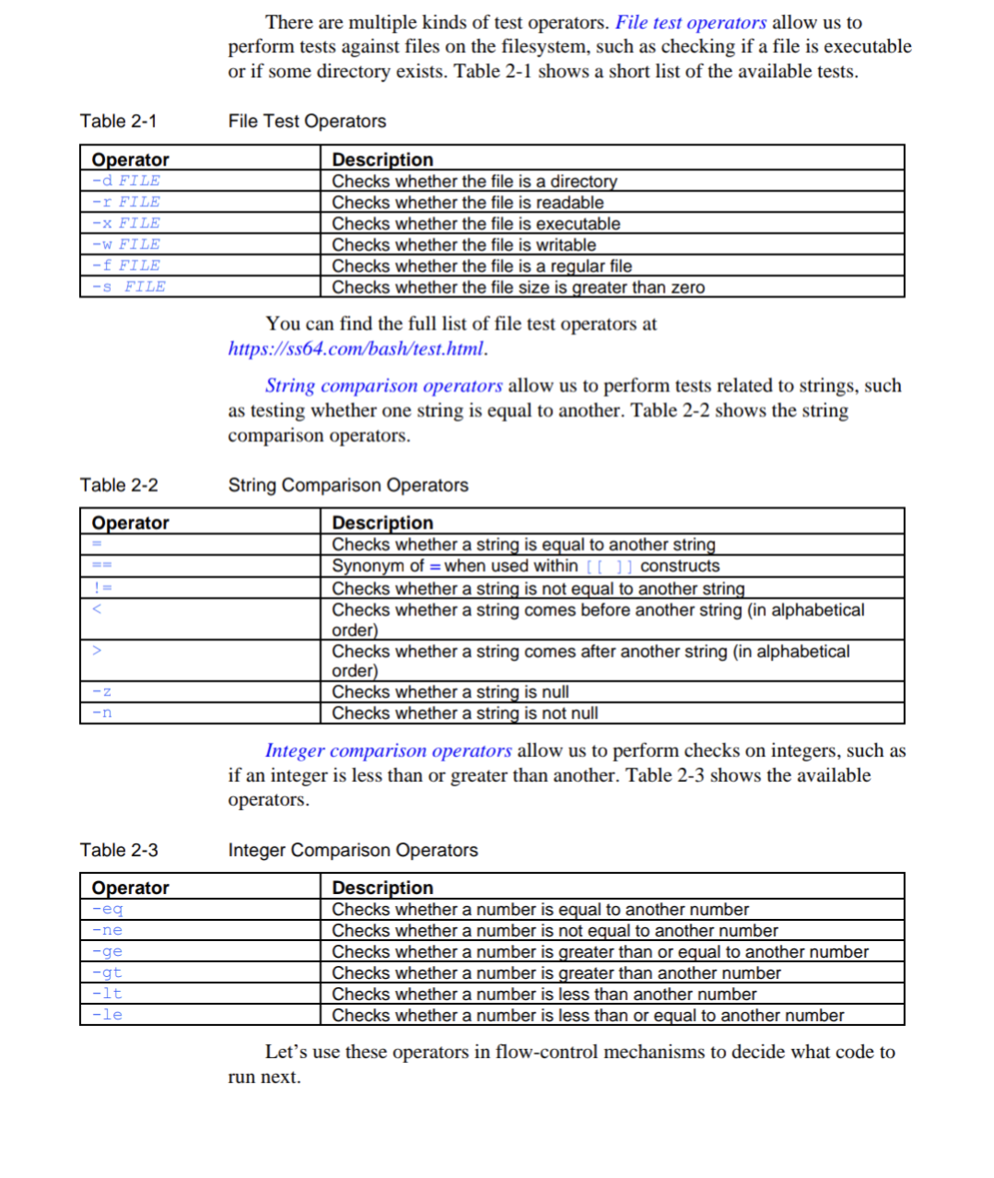

1. In order to use the conditional format

We would enter

If [ ( condition 1 )]; then

Do this

Else;

Do this

fi

fi is how we close the if condition in bash.

In some of the bash installations we might need to use single brackets instead of the double brackets.

#!/bin/bash

Filename = “Black_hat_bash.txt”

If [( -f “$(Filename)” )]; then

Echo “$(Filename) already exists.”

Exit 1

Else

Touch “$(Filename)”

fi

If we save this script and execute it we will see a new file called black_hat_bash.txt get saved in our directory.

Another way of achieving the same can be done through

#!/bin/bash

Filename = “Black_hat_bash.txt”

If [( ! -f “$(Filename)” )]; then

Touch “$(Filename)”

fi

This will create the file in the directory of it's not present.

#!/bin/bash

VARIABLE_ONE="nostarch"

VARIABLE_TWO="nostarch"

if [[ "${VARIABLE_ONE}" == "${VARIABLE_TWO}" ]]; then

echo "They are equal!"

else

echo "They are not equal!"

fi

1. Hzjs

#!/bin/bash

Integer_1 = “10”

Integer_2 = “20”

If [( $“( Integer_1)” gt $“( Integer_2)” )]; then

echo“${Integer_1} is greater than ${Integer_2}”

Else;

echo“${Integer_1} is less than ${Integer_2}”

Fi

1. And command &&

#!/bin/bash

Echo “Hello_world” > output.txt

If [[ -f “output.txt” ]] && [[ -s “output.txt”. ]]; then

echo “ This file exists and it's size is greater than zero”

fi

1. OR command ||

#!/bin/bash

DIR_NAME=”dir_test”

Mkdir “$ {DIR_NAME}”

If [[ -f “${DIR_NAME}” ]] || [[ -d “${DIR_NAME}” ]]; then

echo “${DIR_NAME} is either a file or a directory”

fi

1. Trigger an action if a command is true

If COMMAND;then

#Command was successful

fi

If ! COMMAND;then

# command was unsuccessful

fi

For example:

If touch “output.txt”;then

Echo “File has been created”

fi

1. ELIF command

#!/bin/bash

USER_INPUT=”${1}”

If [[ -z “${USER_INPUT}” ]];then

echo “You must provide an argument”

exit 1

fi

If [[ -f “${USER_INPUT}” ]];then

echo “${USER_INPUT} is a file.”

elif [[ -d “${USER_INPUT}” ]];then

echo “${USER_INPUT} is a directory”

else

echo “${USER_INPUT} is a neither a directory or a file.”

1. Functions are block of code that can be simply reused instead of writing the code over and over again.

To define a new function, enter a name for it,

followed by parentheses (). Then place the code you would like the function to

run within curly brackets {}:

CODE BLOCK:

#!/bin/bash

say_name(){

echo "Black Hat Bash"

}

TO CALL THE FUNCTION

say_name

This will echo black hat bash.

1. Returning Values

Like commands and their exit statuses, functions can return values using the return keyword. If there is no return statement, the function will return the code of the last command it ran. For example, the function in Listing 2-8 returns a different value based on whether the current user is root or not:

#!/bin/bash

***1*** check_if_root(){

***2*** if [[ "${EUID}" -eq "0" ]]; then

return 0

else

return 1

fi

}

***3*** is_root=$(check_if_root)

***4*** if [[ "${is_root}" -eq "0" ]]; then

echo "user is root!"

else

echo "user is not root!"

fi

Explanation:

1 checks is the user is root.

2 runs the current user’s ID and checks if it is equal to zero.

return 0: If the condition $EUID -eq 0 is true (meaning the user is root), the script returns 0, indicating success in the function

EUID for root is 0

1. Loops and loop Controls

They can be used to

# continuously checking if an IP address is online.

# Iterating through a list of IP addresses and running the same exploit again each of them.

# Testing for a certain condition and then running a loop when it is met.For example checking if an IP address is online and if so running a brute force attack against it.

THREE MAIN COMMANDS USED FOR LOOPS ARE :

$ while

$ until

$ for

As well as “break” and “continue” statements for working with loops.

**WHILE**

#!/bin/bash

SIGNAL_TO_STOP_FILE="stoploop"

while [[ ! -f "${SIGNAL_TO_STOP_FILE}" ]]; do

echo "The file ${SIGNAL_TO_STOP_FILE} does not yet exist..."

echo "Checking again in 2 seconds..."

sleep 2

done

3 echo "File was found! exiting…”

Explanation:

! -f "${SIGNAL_TO_STOP_FILE}": This condition checks if the file specified by the SIGNAL_TO_STOP_FILE variable (which is "stoploop" in this case) does not exist. The ! symbol negates the -f operator, which checks for a regular file.

sleep 2: This line pauses the script execution for 2 seconds.

echo "File was found! exiting...": This line, outside the loop, gets executed only after the while loop exits (meaning the "stoploop" file was found). It prints a message indicating the file was found and the script is exiting.

**UNTIL**

While loop keeps on running as long as a specific condition is true , until loop runs as long as a condition is false.

#!/bin/bash

FILE="output.txt"

touch "${FILE}"

until [[ -s "${FILE}" ]]; do

echo "$FILE is empty..."

echo "Checking again in 2 seconds..."

sleep 2

done

echo "${FILE} appears to have some content in it!”

Explain

-s "${FILE}": This condition checks if the size of the file specified by $FILE is zero.

**FOR**

#!/bin/bash

for index in $(seq 1 10); do

echo "${index}"

done

Output will be

1

2

3

4

5

6

7

8

9

10

Another example for loop can be :

#!/bin/bash

for ip_address in "$@"; do

echo "Taking some action on IP address ${ip_address}"

done

Save this script as for_loop_arguments.sh and run it as follows:

$ chmod u+x for_loop_arguments.sh

./for_loop_arguments.sh 10.0.0.1 10.0.0.2 192.168.1.1 192.168.1.2

**Output will be :**

**Taking some action on IP address 10.0.0.1**

**Taking some action on IP address 10.0.0.2**

**--snip**

For loop

#!/bin/bash

for file in $(ls .); do

echo "File: ${file}"

done

This will print out all the files present .

1. Break statement

#!/bin/bash

while true; do

echo "in the loop"

break

done

echo "This code block will be reached”

In this case, the last echo command will be executed.

#!/bin/bash

for file in example_file*; do

if [[ "${file}" == "example_file1" ]]; then

echo "Skipping the first file."

continue

fi

echo "${RANDOM}" > "${file}"

done

1. CASE STATEMENTS

Case statement’s allow you to test multiple conditions in a cleaner way instead of making us use multiple if statements.

We need to use the esac if we want to end the case statement. esac is just case written backwards.

#!/bin/bash

IP_ADDRESS="${1}"

case ${IP_ADDRESS} in

192.168.*)

echo "Network is 192.168.x.x"

;;

10.0.*)

echo "Network is 10.0.x.x"

;;

*)

echo "Could not identify the network."

;;

esac

Save this file as case_ip_address_check.sh

$ chmod u+x case_ip_address_check.sh

$./case_ip_address_check.sh 192.168.12.55

Output =

Network is 192.168.x.x

$./case_ip_address_check.sh 212.199.2.2

Output=

Could not identify the network.

1. TEXT PHRASING AND PROCESSING

$ grep “192.168.45.10” log.txt

This command will return every instance of 192.168.45.10 from log.txt file.

We can search for multiple instances from the same log file

Either using \| or using -e

$ grep “192.168.45.10 \| 10.153.245.16” log.txt

$ grep -e "35.237.4.214" -e "13.66.139.0" log.txt

In the following example, we run the ps command and use grep to filter out a specific line. The ps command lists the processes on the system:

$ ps | grep TTY

By default, grep is case sensitive. We can make our search case insensitive using the -i flag

$ ps | grep -i tty

We can also use grep to exclude lines containing a certain pattern using the -v argument.

$ grep -v "35.237.4.214" log.txt

To print only the matched pattern, and not the entire line at which the matched pattern was found, use -o.

$ grep -o "35.237.4.214" log.txt

1. The awk command is a data processing and extraction Swiss-army knife. You can use it to identify and return specific fields from a file. To see how it works, take another close look at our log file. What if we needed to print just the IP addresses from this file? This is easy to do with awk .

awk specializes in textual data manipulation. When I put is read and matches a pattern ,the action associated is carried out.

$ awk '{print $1}' log.txt

The $1 represents the first field of every line in the file, where the IP addresses are. By default, awk treats spaces or tabs as separators or delimiters.

Using the same syntax, we can print additional fields, such as the timestamps. Listing 2-26 filters the first three fields of every line in the file.

$ awk '{print $1,$2,$3}' log.txt

Similar syntax we can print first and last entry in each line.

$ awk ‘{print $1,$NF}’ log txt

We can also change the default delimiter. For example, if we had a CSV file separated by commas, rather than spaces or tabs, we could pass awk the -F flag to specify the type of delimiter,

$ awk -F ',' '{print $1}' example_csv.txt

We can even use awk to print the first 10 lines of some file. This emulates the behavior of the head Linux command. NR represents the total number of records and is built into awk.

$ awk 'NR < 10' log.txt

You’ll often find it useful to combine grep and awk. For example, you might want to first find the lines in a file containing the IP address 42.236.10.117and then print the HTTP paths this IP made a request to

$ grep "42.236.10.117" log.txt | awk '{print $7}’

1. EDITING STREAM WITH SED

The sed (stream editor) command takes actions on text. For example, it canreplace the text in a file, modify the text in some command’s output, and even delete selected lines from files.

Let’s use sed to replace any mentions of the word Mozilla with the word Godzilla in the log.txt file. We use its s (substitution) command and g (global) command to make the substitution across the whole file, rather than to just the first occurrence.

$ sed 's/Mozilla/Godzilla/g' log.txt

This will output the modified version of the file but won’t change the original version. You can redirect the output to a new file to save your changes:

$ sed 's/Mozilla/Godzilla/g' log.txt > newlog.txt

We could also use sed to remove any whitespace from the file with the / // syntax, which will replace whitespace with nothing, removing it from the

output altogether (Listing 2-32).

$ sed 's/ //g' log.txt

If you need to delete lines of a file, use the d command. In Listing 2-33, 1ddeletes (d) the first line (1).

$ sed '1d' log.txt

Listing 2-33

Deleting the first line with sed

To delete the last line of a file, use the dollar sign ($), which represents the last line, along with d (Listing 2-34).

$ sed '$d' log.txt

Listing 2-34 Deleting the last line with sed

You can also delete multiple lines, such as line 5 and 7 (Listing 2-35).

$ sed '5,7d' log.txt

Listing 2-35 Deleting lines 5 and 7

Lastly, you can print specific line ranges, such as lines 2 through 15 (Listing 2-36).

$ sed -n '2,15 p' log.txt

When you pass sed the -i argument, it will make the changes to the file itself rather than create a modified copy (Listing 2-37).

sed -i '1d' log.txt

1. **Managing Background and Foreground Jobs**

To practice working with foreground and background jobs, let’s run a command directly in the terminal and send it to the background:

$ sleep 100 &

Notice that we can continue working on the terminal while this sleepcommand runs for 100 seconds. You can verify the spawned process is running by using the ps command:

$ ps -ef | grep sleep

user 1827 1752 cons0 19:02:29 /usr/bin/sleep

Now that this job is in the background, we can use the jobs command to see what jobs are currently running (Listing 2-38).

$ jobs

[1]+ Running sleep 100 &

The output shows that the sleep command is in Running state and that its job ID is 1.

We can migrate the job from the background to the foreground by issuing the fg command and the job ID (Listing 2-39).

$ fg %1

sleep 100

To send the job to background we need to use bg command

1. **Keeping a job running after you logout**

If we run a command irrespective of if it is the background and foreground. If we close the terminal , the process will receive a SIGN UP signal and terminate.

Now, if we wanted to keep the job even after the terminal is shut or we have logged out of the window.

To do this we must use the command “nohup” which stands for (nohup)

nohup ./my_script.sh &

The nohup command will create a file named nohup.out with standard output stream data. So, make sure you delete this file if you don't want to leave any traces on the disk.

There are additional ways to run background scripts, such as by plugging into system and service managers like systemd, which provide additional features, such as monitoring that the process is running, restarting it if it isn’t, and capturing failures. We encourage you to read more about systemd if you have such use-cases

at

https://man7.org/linux/man-pages/man1/init.1.html.

1. Bash customization for Penetration Tester

Placing Scripts in Searchable Paths

To see your path we need to search :

echo $PATH

The output might change depending on the operating system you use.

When you write a bash script, place it in a directory such as /usr/local/bin, which, as you can see, is part of the PATH. If you don’t do this, you have a few other options available to you:

• Call the script directly using the full path.

• Change the directory to the one in which your script lives and execute it from there.

• Use aliases (shown in the next section).

• Adding additional paths to the PATH environment variable

The benefit of placing the script in a searchable path is that you can simply call it by its name. You don’t have to provide the full path or have the terminal be in the same directory.

1. ALIASES

Assign name to a full command so that we don't have to type it everytime.

For example, imagine that you often use Nmap with special parameters to scan for all 65,535 ports on a given IP address:

nmap -vv -T4 -p- -sV --max-retries 5 localhost

This command is quite hard to remember. With aliases, we can make it more accessible on the command line or to our scripts. Here, we assign the command to the alias quickmap:

$ alias quicknmap="nmap -vv -T4 -p- -sV --max-retries 5 localhost”

Now we can run the aliased command using the name of the alias:

$ quicknmap

Starting Nmap 7.80 ( https://nmap.org ) at 2023-02-21 22:32 EST

--snip--

PORT STATE SERVICE

631/tcp open ipp

You can even assign an alias to your own scripts:

$ alias helloworld="bash ~/scripts/helloworld.sh”

1. Customizing the Bash Run Commands Profile (bashrc) Customising terminal

.bashrc and .bash_logout are both dot files that are present in the home directory and are used to manager the environment for the terminal.

We can run ls -la on the home directory to look at these files.

If these files don't exist we can go ahead and create these files.

bashrc is used for non login shell. So when we go to bash terminal it will

bash_profile : is used for login shell

So every time we login it should execute the .bash_profile file.

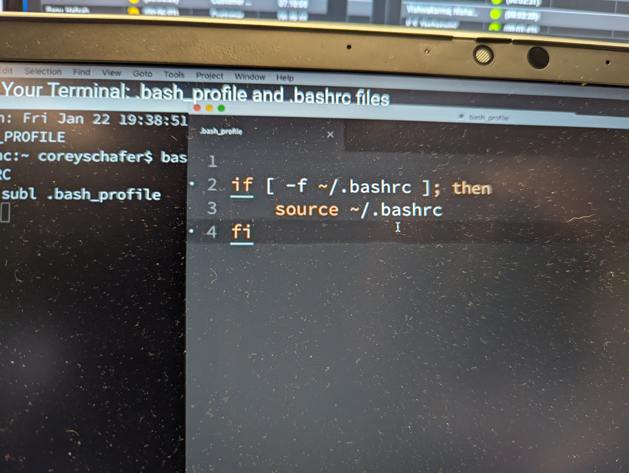

We added this to the bash profile file. So if we log in,it is supposed to run the bash_prpfile but coz of the code it will run this code from bashrc file.

We define environment variables and script variables.

Bash_logout

Importing Custom Scripts

Another way to introduce changes to your bash session is to create a dedicated script that contains pentesting-related customizations and have the ~/.bashrc fileimport it using the source command. To achieve this, create a ~/.pentest.sh file containing your new logic, and then make a one-time modification to ~/.bashrc to import it at the end of the file:

source ~/.pentest.sh

We can also source a bash file using the . command.

. ~/.pentest.sh

What sourcing a command means it re runs the file that has been specified in the command.

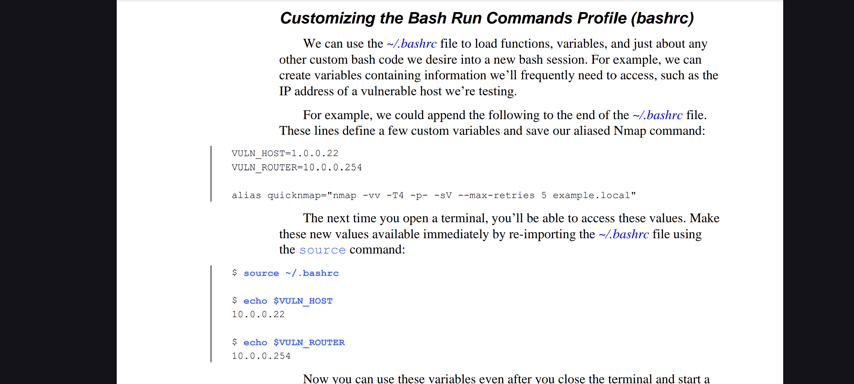

Prompt String 1" and controls how the command prompt appears in your terminal.

PS1 acts like a template that you can customize using special characters and escape sequences. These elements are inserted into the prompt string, allowing you to display information like:

Username (\u)

Hostname (\h)

Current directory (\w or \W)

Time (\t, \T, @`)

Root access status ($ or #)

By modifying the PS1 variable, you can create informative and personalized prompts that suit your workflow. You can set PS1 in your shell configuration files like .bashrc or .bash_profile.

So, instead of typing in

Username@hostname directory ->

We can simply change the .bashrc file

PS1=”\u@\h \W ->”;

export PS1;

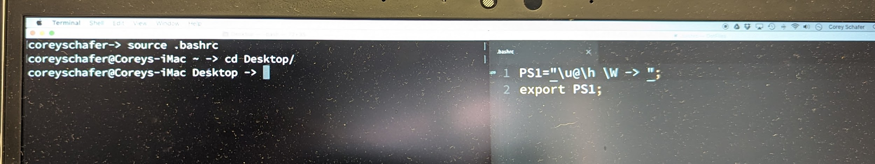

See how we used the source command to execute the bashrc file and then the directory appears before we enter the command.

Even when we change the directories the full name for the directory gets changed.

Capturing Terminal Session Activity

Penetration testing often involves having dozens of terminals open simultaneously, all running many tools that can produce a lot of output. When we find something of interest, we may need some of that output as evidence for later.

To avoid losing track of an important piece of information, we can make use ofsome clever bash.

The script command allows us to capture terminal session activity. One way to use it is to load a small bash script that uses script to save every session to a file for later inspection. The script might look like this:

#!/bin/bash

FILENAME="$(date +%m-%d-%y)_${RANDOM}.log"

if [[ ! -d ~/sessions ]]; then

mkdir ~/sessions

fi

# Starting a script session

script -f -a "~/sessions/${FILENAME}"

_${RANDOM}: This adds an underscore followed by a random number using $RANDOM to the filename, making it unique in case the script is run multiple times in a day.

Having ~/.bashrc load this script, as showed earlier, will result in the creation of the ~/sessions directory containing each terminal session capture in a separate file. The recording stops once you enter exit in the terminal or close the entire terminal window.

1. EXERCISE 2

In this exercise, we’ll write a bash script that accepts two arguments: a name

(for example, mysite) and a target domain (for example, nostarch.com). The script

should also be able to do the following:

1. Throw an error if the arguments are missing and exit using the right status

code.

2. Ping the domain and return an indication of whether the ping was

successful or not.

3. Write the results to a CSV file containing the following information:

a. The name provided to the script

b. The target domain provided to the scriptc. The ping result (either success or failure)

d. The current date and time

Like most tasks in Bash, there are multiple ways to achieve this goal. At

https://github.com/dolevf/Black-Hat-Bash/blob/master/ch02/exercise_solution.sh,

you can find an example solution to this exercise.

Certainly! Below is a Bash script that fulfills the given requirements. This script takes two arguments (a name and a target domain), checks if the arguments are provided, pings the domain, and logs the results to a CSV file.

#!/bin/bash

# Check if the required arguments are provided

if [ "$#" -ne 2 ]; then

echo "Usage: $0 <name> <target_domain>"

exit 1

fi

# Assign arguments to variables

NAME=$1

TARGET_DOMAIN=$2

# Ping the domain

PING_RESULT=$(ping -c 1 $TARGET_DOMAIN > /dev/null 2>&1)

if [ $? -eq 0 ]; then

RESULT="success"

else

RESULT="failure"

fi

# Get the current date and time

CURRENT_DATE=$(date "+%Y-%m-%d %H:%M:%S")

# Write the results to a CSV file

echo "$NAME,$TARGET_DOMAIN,$RESULT,$CURRENT_DATE" >> ping_results.csv

# Output the result

echo "Ping result for $TARGET_DOMAIN: $RESULT"

exit 0

Explanation:

Argument Check:

The script checks if the number of arguments provided is exactly two. If not, it prints a usage message and exits with status code 1.

Assign Arguments:

The script assigns the first argument to NAME and the second to TARGET_DOMAIN.

Ping the Domain:

The ping command is used to ping the target domain with 1 packet (-c 1).

The result of the ping command is redirected to /dev/null to suppress output.

The exit status of the ping command ($?) is checked to determine if the ping was successful. If the exit status is 0, the result is "success"; otherwise, it is "failure".

Get Current Date and Time:

The date command is used to get the current date and time in the format YYYY-MM-DD HH:MM:SS.

Write Results to CSV:

The script appends the results to a file named ping_results.csv in the format: name,target_domain,result,current_date.

Output the Result:

The script prints a message indicating whether the ping was successful or not.

Usage:

To use this script, save it to a file, for example, ping_script.sh, and make it executable:

chmod +x ping_script.sh

Then run the script with the name and target domain as arguments:

./ping_script.sh mysite nostarch.com

The results will be appended to ping_results.csv in the same directory as the script.

Like most tasks in Bash, there are multiple ways to achieve this goal. At

https://github.com/dolevf/Black-Hat-Bash/blob/master/ch02/exercise_solution.sh,

you can find an example solution to this exercise.

1. VULNERABLE ENVIRONMENT
2. To set up bash as the default script

Sudo usermod - -shell /bin/bash kali

After we have set it up we can use the command

su - kali

To enable our new default shell

1. SETTING UP THE TARGET ENVIRONMENT

We can either we get the lab from

if you ever need to redeploy the lab from scratch in a fresh installation

of Kali, you can do so by executing the init.sh script at

https://github.com/dolevf/Black-Hat-Bash/blob/master/lab/init.sh:

$ cd ~/Black-Hat-Bash/lab

$ chmod u+x init.sh

$ ./init.sh

Or preferably we can set it up manually.

1. Now we will install docker and docker compose

Let’s first configure our sources to use Debian’s current stable version of Docker’s community edition, docker-ce, using the following commands.

We use printf to add Docker’s Advanced Package Tool (APT) repository to the APT package-source database file. The tee command reads from standard input stream and writes to a file:

**$ printf '%s\n' "deb https://download.docker.com/linux/debian bullseye stable" |**

**sudo tee /etc/apt/sources.list.d/docker-ce.list**

Next, download and import Docker’s keyring to ensure that the repository is validated and all packages installed from that repository are cryptographically verified. We use curl to download the key and pipe it to the gpg command, which will then store it in the required folder:

**$ curl -fsSL https://download.docker.com/linux/debian/gpg | sudo gpg --dearmor -o**

**/etc/apt/trusted.gpg.d/docker-ce-archive-keyring.gpg**

Finally, run another update to refresh the repository database and install the Docker components:

$ sudo apt update -y

$ sudo apt install docker-ce docker-ce-cli containerd.io -y

To verify that you have Docker Compose running correctly, use the following:

$ docker compose --help

Next, make sure the Docker process will automatically start upon system reboot by running this command:

$ sudo systemctl enable docker - -now

Docker requires the use of sudo, which can get a little inconvenient. If you want to avoid having to enter sudo before executing Docker-related commands, add the kali user to the docker Linux group:

$ sudo usermod -aG docker $USER

Once you’ve done this, you shouldn’t need sudo to run Docker commands

1. Cloning the Book’s Repository

You can find the lab’s files in the open source Black Hat Bash repository at https://github.com/dolevf/Black-Hat-Bash. This repository contains the Docker configurations needed to build the lab, as well as all of the bash scripts mentioned in the future chapters of this book.

Kali comes preloaded with git, which you can use to clone and download the Black Hat Bash repository. To do so, run the following:

$ git clone <https://github.com/dolevf/Black-Hat-Bash.git>

Next, move into the repository’s root directory and take a quick look at its contents:

$ cd Black-Hat-Bash && ls -l

--snip--

drwxr-xr-x 2 kali kali 4096 Jul 22 23:07 ch01

drwxr-xr-x 2 kali kali 4096 Jul 22 23:07 ch02

drwxr-xr-x 2 kali kali 4096 Jul 22 23:07 ch03

drwxr-xr-x 2 kali kali 4096 Jul 22 23:07 ch04

drwxr-xr-x 2 kali kali 4096 Jul 22 23:07 ch05

--snip–

As you can see in the output, the repository’s contents are organized into directories for each of the book’s chapters. The repository also includes a lab directory, which is what we’ll use to set up the lab in the next section.

1. Deploying Docker Containers

The contents of the lab directory in the Black Hat Bash repository control all networking infrastructure, machines, and applications used within the lab. This directory includes a run.sh script file. By running this script without any arguments, you can see that it is used to deploy, tear down, rebuild, clean, and check the status of our environment:

**$ cd lab**

**$ ./run.sh**

Usage: ./run.sh deploy | teardown | rebuild | cleanup | status

**deploy | build images and start containers**

**teardown | stop containers**

**rebuild | rebuilds the lab from scratch**

**cleanup | stop containers and delete containers and images**

**status | check the status of the lab**

Let’s start by creating the lab by using the deploy argument. Note that when you execute the deployment, you’ll be prompted for your kali user password:

**$ ./run.sh deploy**

The initial deployment of the lab environment will take a few minutes to complete. To monitor the progress of the installation, you’ll need to open a new terminal session and tail the log file located within the repository’s lab directory, as so:

**$ tail -f ~/Black-Hat-Bash/lab/log.txt**

When the tail -f (follow) command is used against a file, it provides a live view of any new lines added to the end of the file. This is useful for keeping an eye on log files, which frequently have new information written to them.

NOTE: Because the lab setup downloads software such as operating system images and

other applications, this deployment could take some time, depending on the network

connection you have and the compute resources allocated to the host running the lab.

1. Testing and Verifying the Containers

Once the log file indicates the process is complete, it should tell you whether the lab was set up correctly. We can also run a few commands to verify this. First,let’s execute a status check using the run.sh script, this time with the statusargument. If all the checks pass, you should get the following output:

**$ ./run.sh status**

Lab is up.

We can also list all our lab’s running Docker containers using the docker list command:

$ docker ps -–format "{{.Names}}"

p-web-01

p-web-02

p-ftp-01

c-jumpbox-01

c-db-01

c-db-02

c-syslog-01

c-backup-01

c-redis-01

1. THE NETWORK INFRASTRUCTURE

Lab consists of 9 machines running in docker containers as well as two networks.

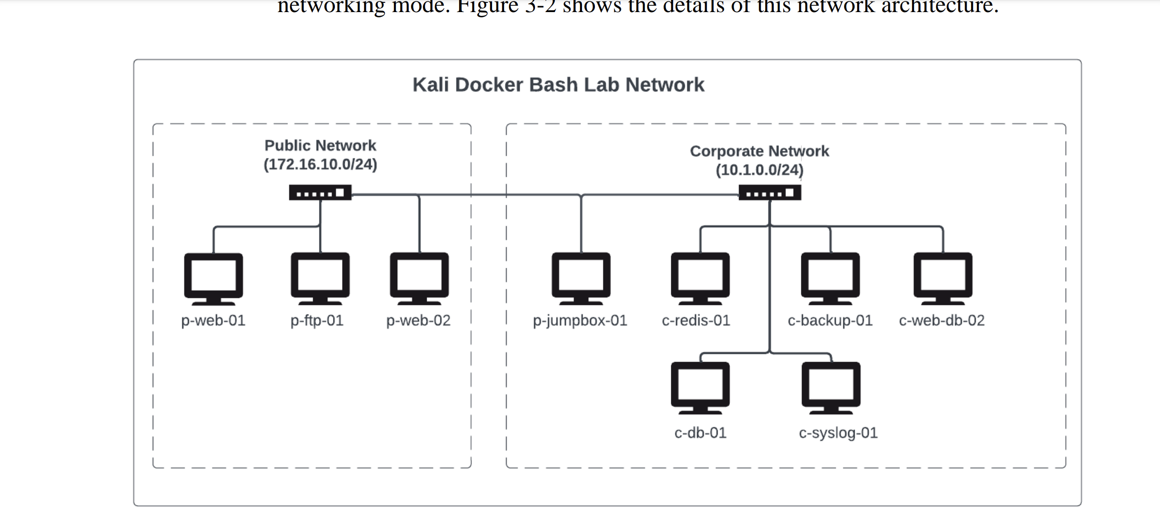

1. The Public Network

The network on the left side of Figure 3-2 is the public network, where our fake internet hosting company, ACME Infinity Servers, hosts its customer’swebsites and resources. The two company websites you’ll find in this network belong to ACME Impact Alliance and ACME Hyper Branding.

The public network has an IP address CIDR range of 172.16.10.0/24 andcontains four machines (whose names are prefixed with p-). It is also public facing, meaning we’ll likely test the machines with access to this network before any other, as they constitute possible entry points into the network.

1. The Corporate Network

The second network is the corporate network. ACME Infinity Servers uses this private network to hosts its supporting infrastructure on the back-end. As you can see, the corporate network has an IP address CIDR range of 10.1.0.0/24 and

contains five machines (whose names are prefixed with c-). This network is not public facing, meaning the machines in this network don’t have internet connectivity, and we won’t test them until we’re able to take over one or more of the machines on the public network, which will serve as our launchpad to the corporate network.

1. Check that up addresses have been configured correctly{both of them appear in the IPrange specified above} for both the public and corporate network

Ip addr | grep “br_”

1. **The Machines**

The nine machines that make up the lab environment follow a simple naming convention. The first character of the name determines what network the machine belongs to. For example, if the machine name starts with a p, it belongs to the public network; likewise, if it starts with a c, it belongs to the corporate network.

The next word describes the machines’ functions or main technology stack, such as web, ftp, jumpbox, or redis. Finally, a number is used to distinguish similar machines, such as p-web-01 and p-web-02.

1. 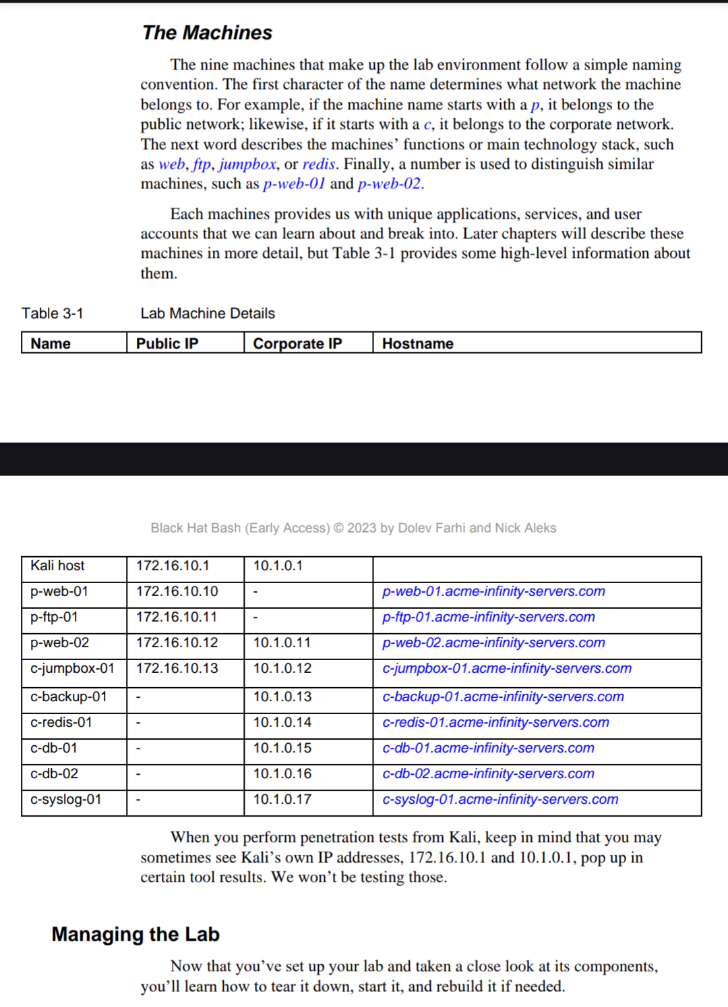

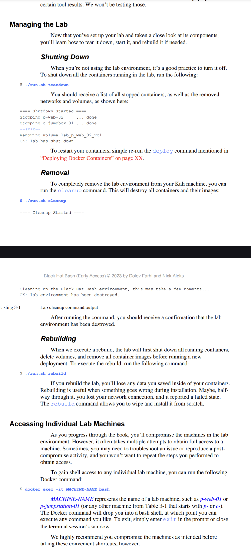

1. INSTALLING ADDITIONAL HACKING TOOLS

We will make a new directory which will have all the tools that we would require throughout the labs.

We will run the following commands

cd ~

mkdir tools

1. Wappalyzer

Wappalyzer is a tool used to identify the technologies behind a website. This can include things like:

* Content management systems (CMS) like WordPress or Drupal
* Ecommerce platforms like Shopify or Magento
* Web frameworks like React or Angular
* Server software like Apache or Nginx
* Analytics tools like Google Analytics or Hotjar

Wappalyzer also has a paid API that you can use to programmatically identify the technologies used by websites. This can be useful for businesses that need to track the technology choices of their competitors or for developers who want to see what technologies are being used by popular websites.

Once we figure out which dependies a website is using we can therby look for vulnerabilities

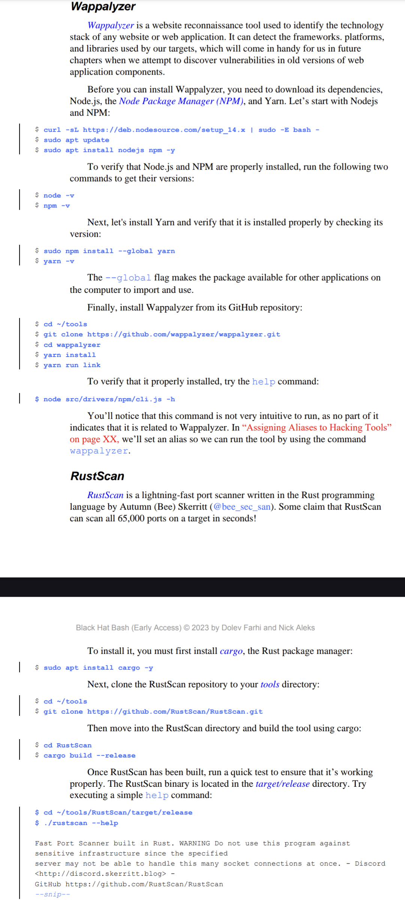

1. RUSTSCAN

RustScan is a port scanner tool designed for speed and efficiency. It's particularly useful for network administrators, penetration testers, and security researchers.

Here's a breakdown of its key features:

* Fast Scanning: RustScan is known for its exceptional speed compared to other port scanners. It achieves this through techniques like asynchronous I/O and multi-threading.
* Port Detection: It identifies open ports on target systems across a range of IP addresses. This helps in understanding what services are running on a device and can be crucial for security assessments.
* Extensibility: RustScan offers a scripting engine that allows you to write custom scripts in languages like Python, Lua, and Shell. These scripts can be triggered after a scan to perform further analysis based on the discovered open ports.
* Accessibility: It's one of the first penetration testing tools built with accessibility in mind, ensuring a wider range of users can benefit from it.

In summary, RustScan is a valuable tool for anyone who needs to quickly and efficiently scan networks to identify open ports and understand the services running on devices.

1. 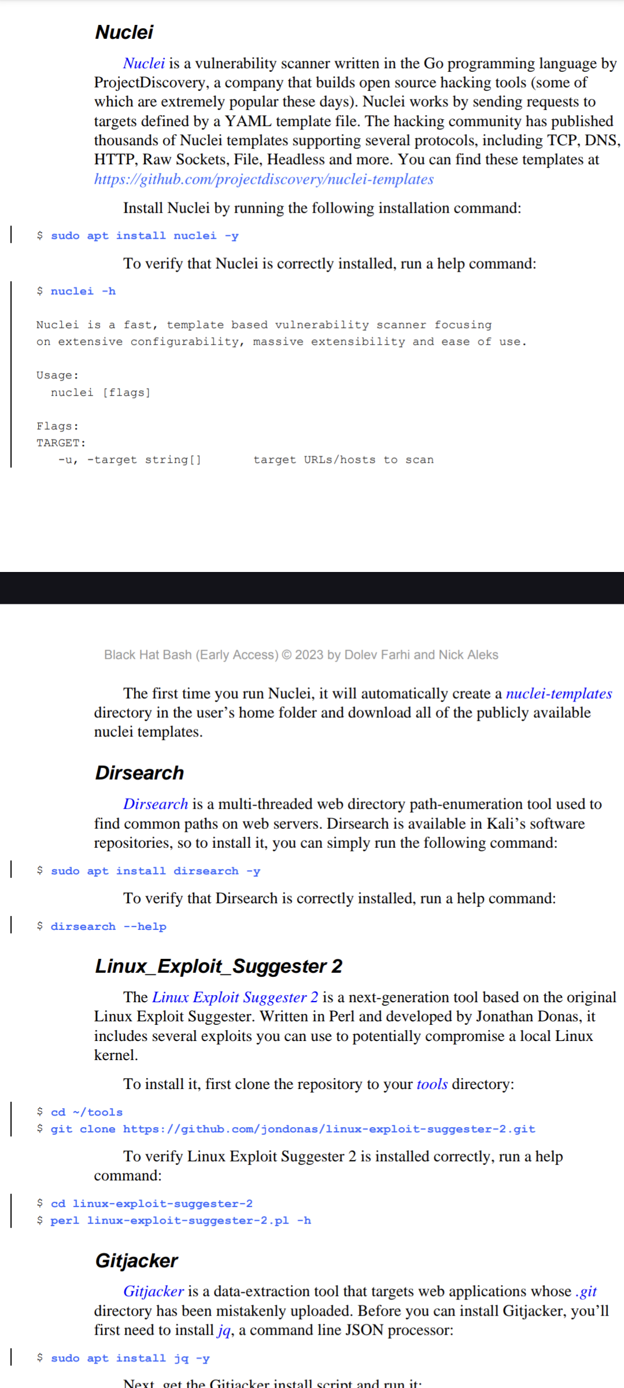
2. 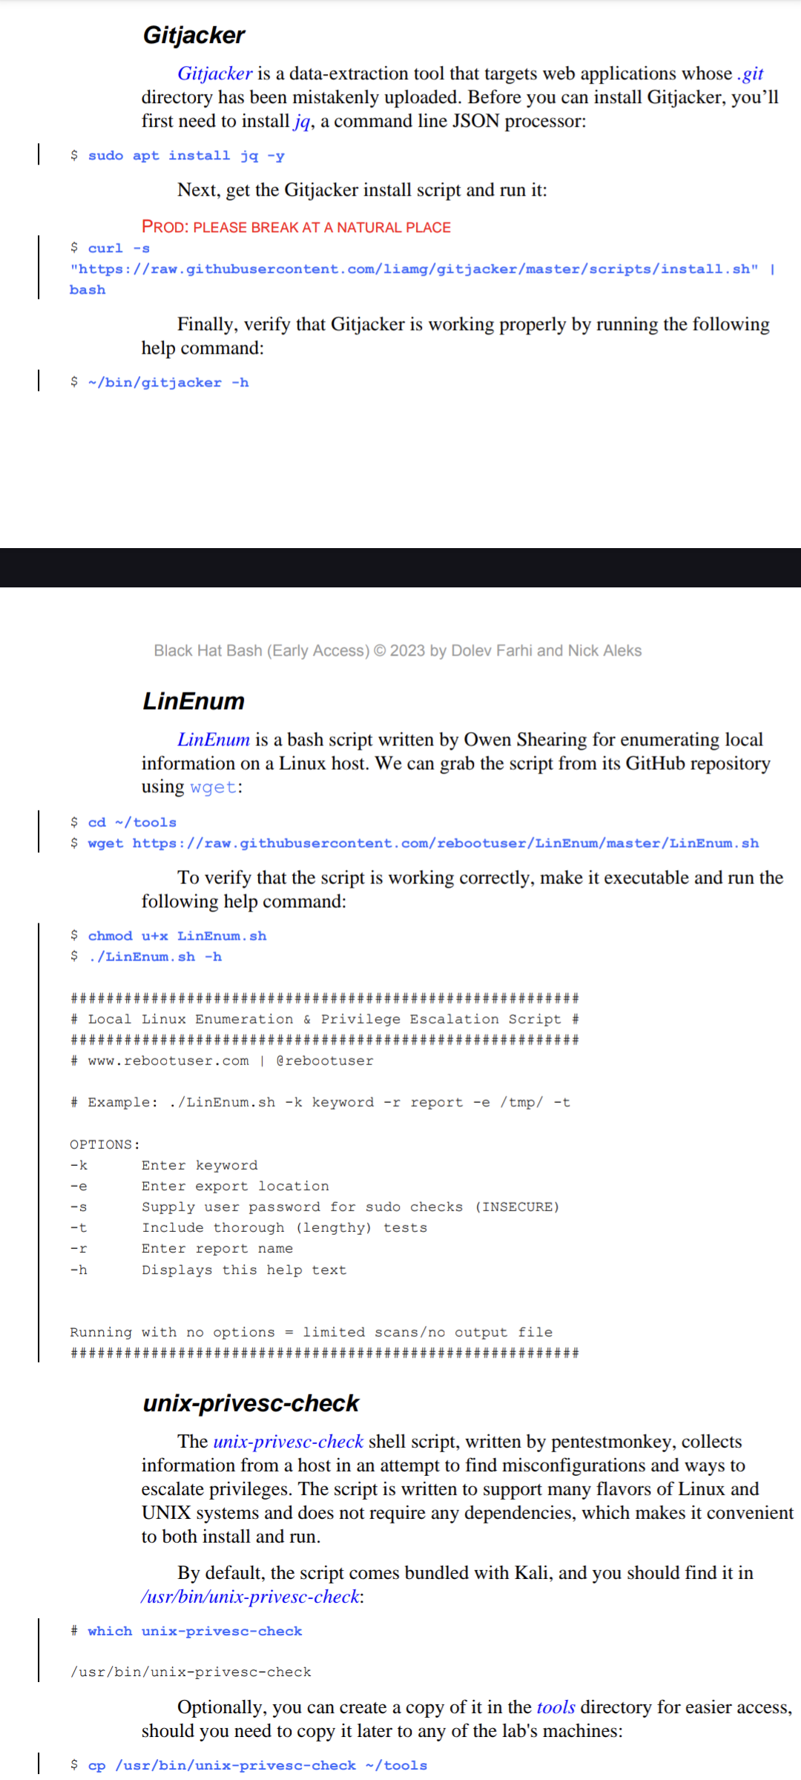
3. 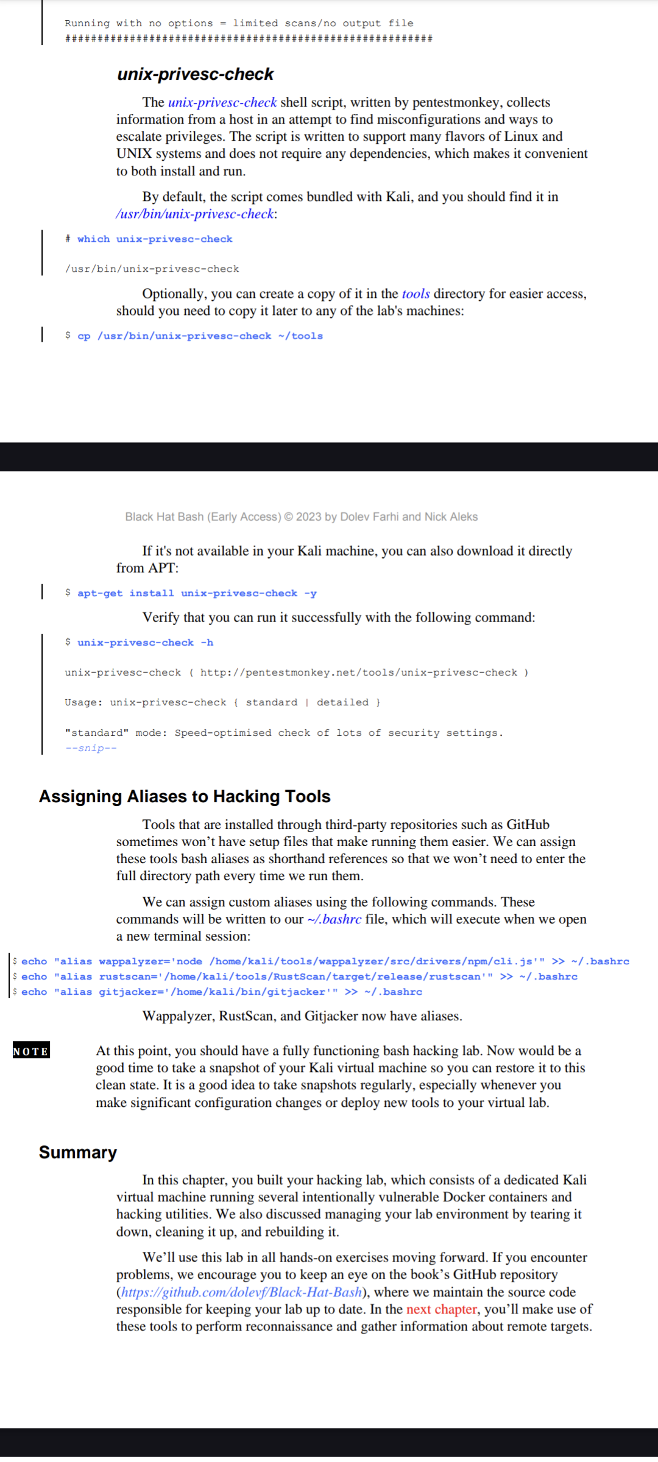
4. RECONNAISSANCE
5. Generating a list of consecutive IP Addresses

Imagine that you need to create a file containing a list of IP addresses from 172.16.10.1 to 172.16.10.254. While you could write all 254 addresses by hand, this would be time-consuming. Let’s use bash to automate the job! We’ll consider three strategies: using the seq command in a for loop, using brace expansion with echo, and using brace expansion with printf.

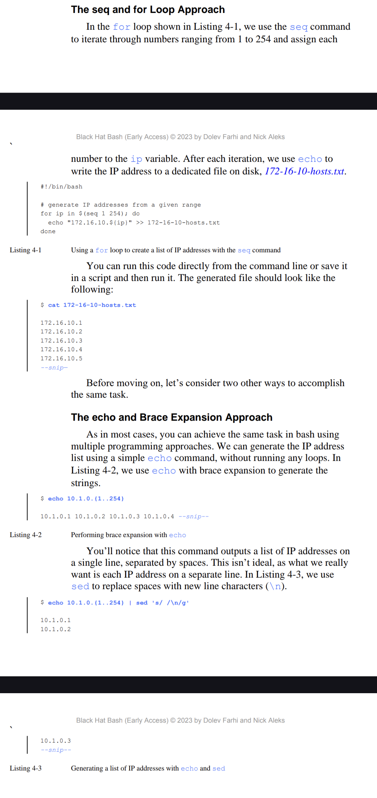

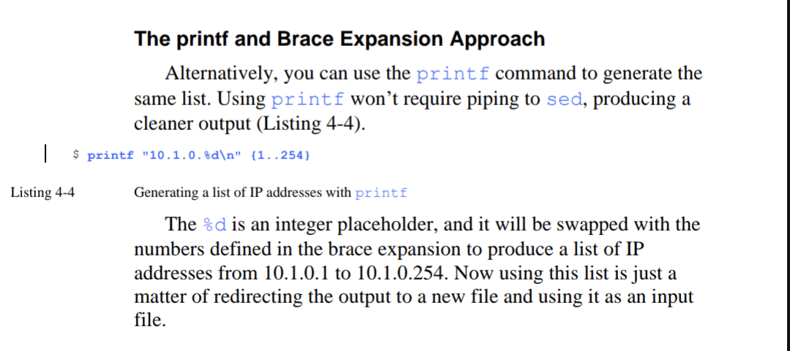

1. COMPILING LIST OF POSSIBLE SUBDOMAINS

Companies tend to host their services and application on dedicated subdomains. These subdomains can be anything, but more often than not, companies use names that make sense to humans and are easy to enter into a web browser.

For example, you might find the helpdesk portal at helpdesk.example.com, a monitoring system at monitoring.example.com, the continuous integration system at jenkins.example.com, the email server at mail.example.com, and the file transfer server at ftp.example.com.

How can we generate a list of possible subdomains for our target? Bash makes this very easy. First, we’ll need a list of common subdomains. You can find such a list built into Kali at

/usr/share/wordlists/amass/subdomains-top1mil-110000.txt

or

/usr/share/wordlists/amass/bitquark_subdomains_top100K.txt.

For the purposes of this example, we’ll use the subdomain list at

https://github.com/dolevf/Black-Hat-

Bash/blob/master/ch04/subdomains-1000.txt.

Download it and save it in your home directory. The file contains one subdomain per line without an associated parent domain. You’ll have to join each subdomain with the target’s parent domain to form a fully qualifieddomain name (FQDN). As in the previous section, we’ll show two strategies for accomplishing this task: using a while loop and using sed.

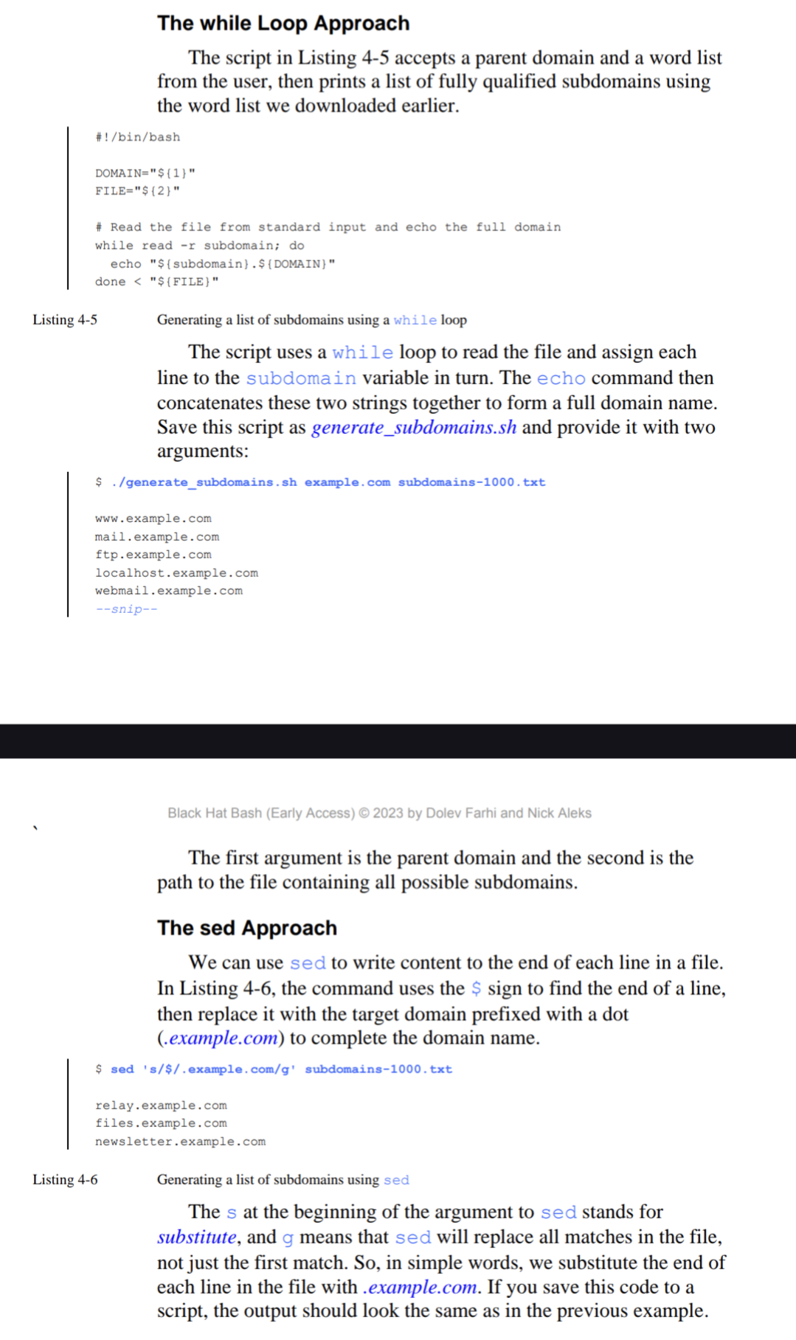

The while loop above simply adds all the items from the list file and prepends it to the domain name.Saves jr ro

The part done < "${FILE}" in the Bash script you provided serves two purposes:

* Loop Termination: The keyword done marks the end of the while loop. Everything within the while loop (including the read command and the line containing echo) will keep repeating as long as there are lines left to read in the file. The done keyword tells the script when to stop iterating.
* Input Redirection: The < "${FILE}" part redirects the content of the file specified by the $FILE variable into the standard input of the while loop. Standard input is typically where a program receives its data by default when it's not explicitly provided as an argument. In this case, instead of the script taking input from the keyboard, it reads each line of the file as if it were typed one by one.

1. HOST DISCOVERY : When we need to attack a network we need to know what all hosts does it contain and which of the hosts are live and which ones we can attack?

There are several ways we can achieve this :

1. PING : It is the process of sending packet to a host and waiting for a reply to check if the host is live.

**#!/bin/bash**

**FILE="${1}"**

**1 while read -r host; do**

**2 if ping -c 1 -W 1 -w 1 "${host}" &> /dev/null; then**

**echo "${host} is up."**

**fi**

**3 done < "${FILE}".**

What does this command do

This Bash script reads a list of hostnames or IP addresses from a specified file and checks if each host is reachable using the ping command. Here's a breakdown of what each part does:

* FILE="${1}": This line assigns the first argument passed to the script to the variable FILE. This argument should be the name of the file containing the list of hosts.
* The while read -r host; do loop reads each line of the file specified by FILE. For each line, it assigns the value to the variable host.
* if ping -c 1 -W 1 -w 1 "${host}" &> /dev/null; then: This line sends a single ping (-c 1) to the current host with a timeout of 1 second (-W 1 and -w 1). The output of the ping command is redirected to /dev/null to suppress it.

We also use the arguments -W 1 (to set a timeout in seconds) and -w 1 (to set a deadline in seconds) to limit how long ping will wait to receive a response. This is important because we don’t want ping to get stuck on an unresponsive IP address; we want it to continue reading from the file until all 254 hosts are tested.

* echo "${host} is up.": If the ping command succeeds (i.e., the host responds within the specified timeout), this line prints a message indicating that the host is up.
* fi: Ends the if block.
* done < "${FILE}": Ends the while loop, specifying that it should read from the file defined by FILE.

Save this code to a file named multi_host_ping.sh and run itwhile passing the hosts file. You should see that it picks up a few live hosts:

$ ./multi_host_ping.sh 172-16-10-hosts.txt

Note : Some systems are hardened to not to respond to ping request, so this method might not provide all the different hosts that we need to know when attacking a system.

Also, ping command does not have a timeout. So therefore we require to set a timeout flag so that it does not run forever.

timeout 5s ping 8.8.8.8

1. NMAP

-sn. Performs a ping sweep(and disables port scanning )

NMAP -sn 172.16.10.0/24

This will make NMAP send ICMP packets to discover running hosts.

There is a lot of text in this output. With a bit of bash magic, we can get a cleaner output by extracting only the IP addresses that were identified as being alive by using the grep and awk commands(Listing 4-8).

$ nmap -sn 172.16.10.0/24 | grep "Nmap scan" | awk -F'report for ' '{print $2}'

172.16.10.1

172.16.10.10

--snip- -

* | awk -F'report for ' '{print $2}':
* |: Another pipe operator, passing the filtered output from grep to awk.

awk -F'report for ' '{print $2}': This uses awk, a text processing tool, to further process the filtered lines.

* -F'report for ': This sets the field separator to "report for ".
* '{print $2}': This prints the second field from each line, which corresponds to the IP address or hostname following "report for ".

1. ARP

We will use ARP scan to find local hosts on a network. ARP maps the MAC addresses.

ARP is layer 2 in the OSI model. Which means that we can only action this while we are on the local network and cannot be actioned over the Internet.

Note that arp-scan requires root privileges to run; this is because it uses functions to read and write packets that require elevated privileges. At its most basic form, you can run it by executing the arp-scan command and passing a single IP address as an argument:

**$ sudo arp-scan 172.16.10.10 -I br_public**

The -I option specifies the network interface to use for the scan. br_public is the name of the network interface through which the ARP requests will be sent.

We also need to tell arp-scan which network interface to send packets on, as there are a few network interfaces in Kali. To achieve this, we use the -I argument. The br_public interface corresponds to the 172.16.10.0/24 network in the lab.

To scan entire networks, you can pass arp-scan a CIDR range, such as /24. For example, the following command scans all IP addresses between 172.16.10.1 and 172.16.10.254:

$ sudo arp-scan 172.16.10.0/24 -I br_public

Lastly, you can make use of the hosts file you created in “Generating a List of Consecutive IP addresses” on page XX as input to arp-scan:

$ sudo arp-scan -f 172-16-10-hosts.txt -I br_public

The output generated by arp-scan should look like the following:

172.16.10.10 02:42:ac:10:0a:0a (Unknown: locally administered)

172.16.10.11 02:42:ac:10:0a:0b (Unknown: locally administered)

172.16.10.12 02:42:ac:10:0a:0c (Unknown: locally administered)

172.16.10.13 02:42:ac:10:0a:0d (Unknown: locally administered)

It consists of three fields: the IP address, the MAC address, and vendor details, identified by the first three octets of the MAC address. In this scan, the tool identified four hosts on the network that responded to ARP packets.

EXCERCISE :

CREATE bash script that sends email to us and adds the host to hosts.txt file each time a new IP address enters the network.

**#!/bin/bash**

**# sends a notification upon new host discovery**

**KNOWN_HOSTS="172-16-10-hosts.txt"**

**NETWORK="172.16.10.0/24"**

**INTERFACE="br_public"**

**FROM_ADDR="kali@blackhatbash.com"**

**TO_ADDR="security@blackhatbash.com"**

**1 while true; do**

**echo "Performing an ARP scan against ${NETWORK}..."**

**2 sudo arp-scan -x -I ${INTERFACE} ${NETWORK} | while read -r line; do**

**3 host="$(echo "${line}" | awk '{print $1}')"**

**4 if ! grep -q "${host}" "${KNOWN_HOSTS}"; then**

**echo "Found a new host: ${host}!"**

**5 echo "${host}" >> "${KNOWN_HOSTS}"**

**6 sendemail -f "${FROM_ADDR}" \**

**-t "${TO_ADDR}" \**

**-u "ARP Scan Notification" \**

**-m "A new host was found: ${host}"**

**fi**

**done**

**sleep 10**

**done**

This Bash script continuously monitors a specified network for new hosts using ARP scan and sends an email notification when a new host is discovered. Here’s a detailed breakdown of each part of the script:

Variable Declarations:

We define these variables

KNOWN_HOSTS="172-16-10-hosts.txt": The file that keeps track of known hosts.

NETWORK="172.16.10.0/24": The network range to scan.

INTERFACE="br_public": The network interface to use for the scan.

FROM_ADDR="kali@blackhatbash.com": The sender's email address for notifications.

TO_ADDR="security@blackhatbash.com": The recipient's email address for notifications.

Infinite Loop:

* while true; do: Starts an infinite loop that runs the following commands continuously.

Perform ARP Scan:

echo "Performing an ARP scan against ${NETWORK}...": Outputs a message indicating that an ARP scan is being performed.

sudo arp-scan -x -I ${INTERFACE} ${NETWORK}: Performs an ARP scan on the specified network using the specified interface. The -x option provides output suitable for piping into other programs.

Process Each Line of ARP Scan Output:

* while read -r line; do: Reads each line of the ARP scan output.

Extract Host IP Address:

host="$(echo "${line}" | awk '{print $1}')": Extracts the host's IP address from the ARP scan output line using awk.

Check if Host is Known:

if ! grep -q "${host}" "${KNOWN_HOSTS}"; then: Checks if the host IP address is already in the KNOWN_HOSTS file using grep.

New Host Found:

echo "Found a new host: ${host}!": Outputs a message indicating that a new host has been found.

echo "${host}" >> "${KNOWN_HOSTS}": Appends the new host's IP address to the KNOWN_HOSTS file.

Send Email Notification:

sendemail -f "${FROM_ADDR}" -t "${TO_ADDR}" -u "ARP Scan Notification" -m "A new host was found: ${host}": Sends an email notification using the sendemail command, with the specified sender and recipient addresses, subject, and message body.

Sleep:

sleep 10: Pauses the script for 10 seconds before the next iteration of the loop.

If you run this script, you should receive an email whenever a new host is discovered. To properly send emails, you’ll need to configure a mail transfer agent (MTA) such as Postfix on the system. Refer to the documentation at

https://postfix.org/documentation.html

for more information.

You can download the script at

https://github.com/dolevf/Black-Hat-Bash/blob/master/ch04/host_monitor_notification.sh.

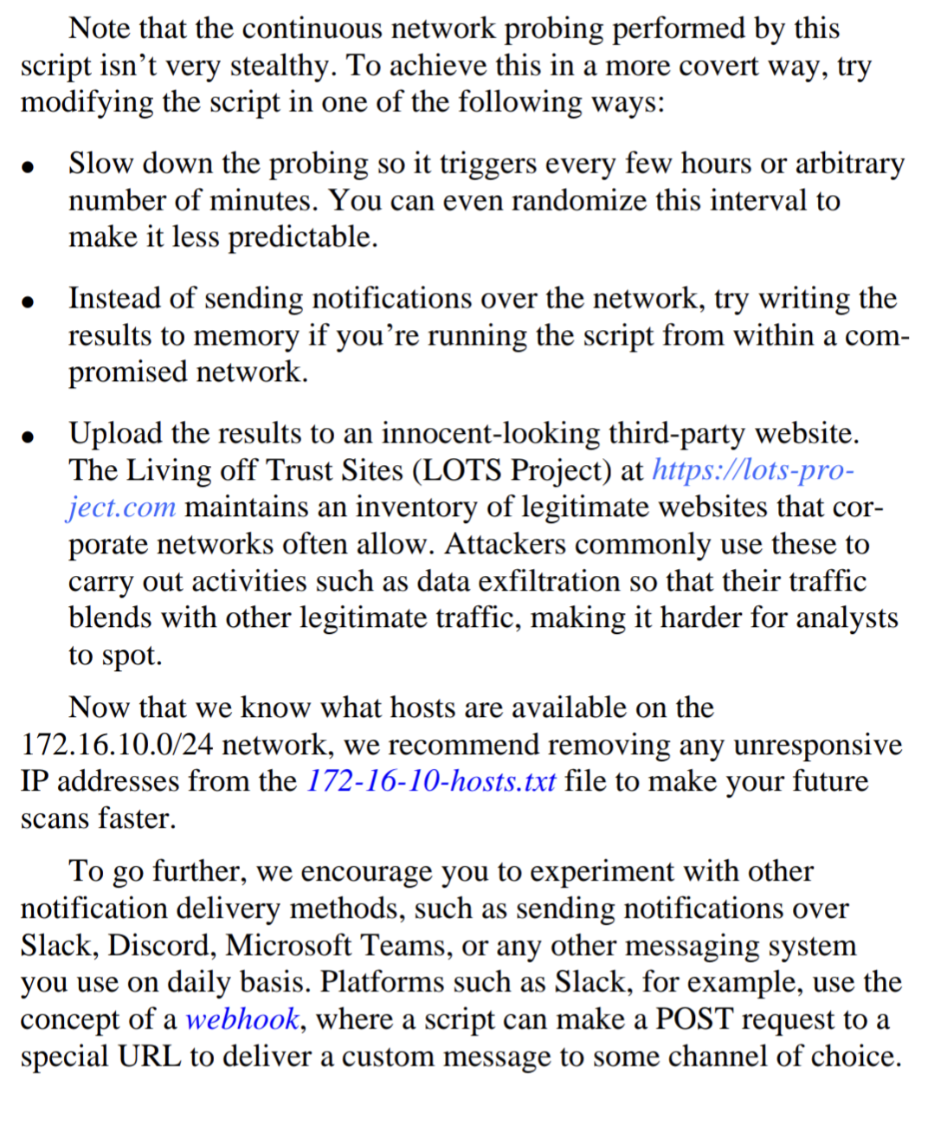

1. PORT SCANNING

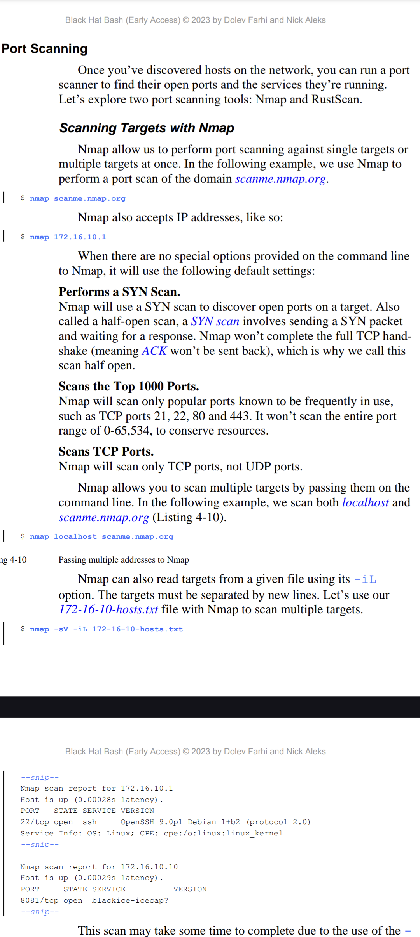

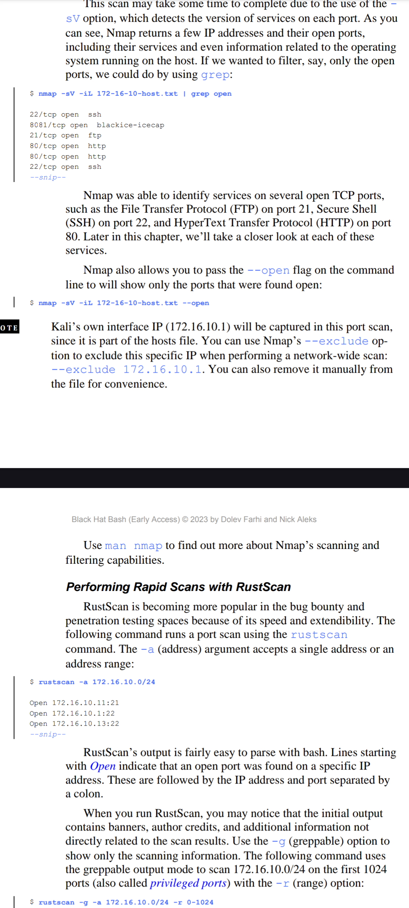

**$ rustscan -g -a 172.16.10.0/24 -r 0-1024 | awk -F'->' '{print $1,$2}' | tr -d '[ ]’**

Now the output is more grep friendly. If we wanted to parse it, all we’d need to do is pass the delimiter ->, which separates the IP address and port, with awk:

$ rustscan -g -a 172.16.10.0/24 -r 0-1024 | awk -F'->' '{print $1,$2}'

This command outputs two fields, the IP address and the port. If we wanted to get rid of the [] surrounding the port number, we can do this with the tr command and the -d (delete) argument followed by the characters to delete:

$ rustscan -g -a 172.16.10.0/24 -r 0-1024 | awk -F'->' '{print $1,$2}' | tr -d '[ ]'

The commands provided perform a network scan using rustscan and then process the output to extract and format the IP addresses and port numbers.

Network Scan with Rustscan:

$ rustscan -g -a 172.16.10.0/24 -r 0-1024

rustscan is a fast network scanner.

-g option enables greppable output, which is more structured and easier to parse.

-a 172.16.10.0/24 specifies the IP address range to scan (subnet 172.16.10.0/24).

-r 0-1024 specifies the port range to scan (ports 0 through 1024).

Parse with awk:

| awk -F'->' '{print $1,$2}'

The output of rustscan is piped to awk.

-F'->' sets the field delimiter to ->, which separates the IP address and port in the rustscan output.

{print $1,$2} prints the first and second fields, which correspond to the IP address and the port number, respectively.

Remove Brackets with tr:

| tr -d '[ ]'

The output of awk is piped to tr.

tr -d '[ ]' deletes the [ and ] characters from the output, cleaning up the port numbers by removing any surrounding brackets.

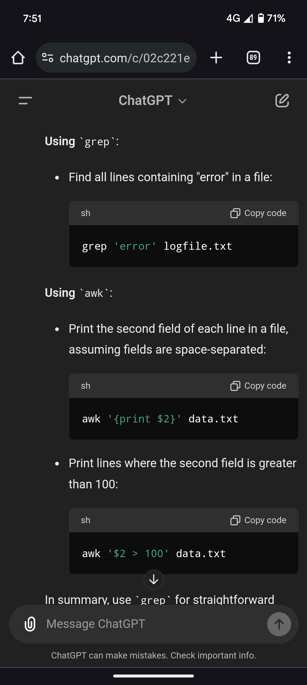

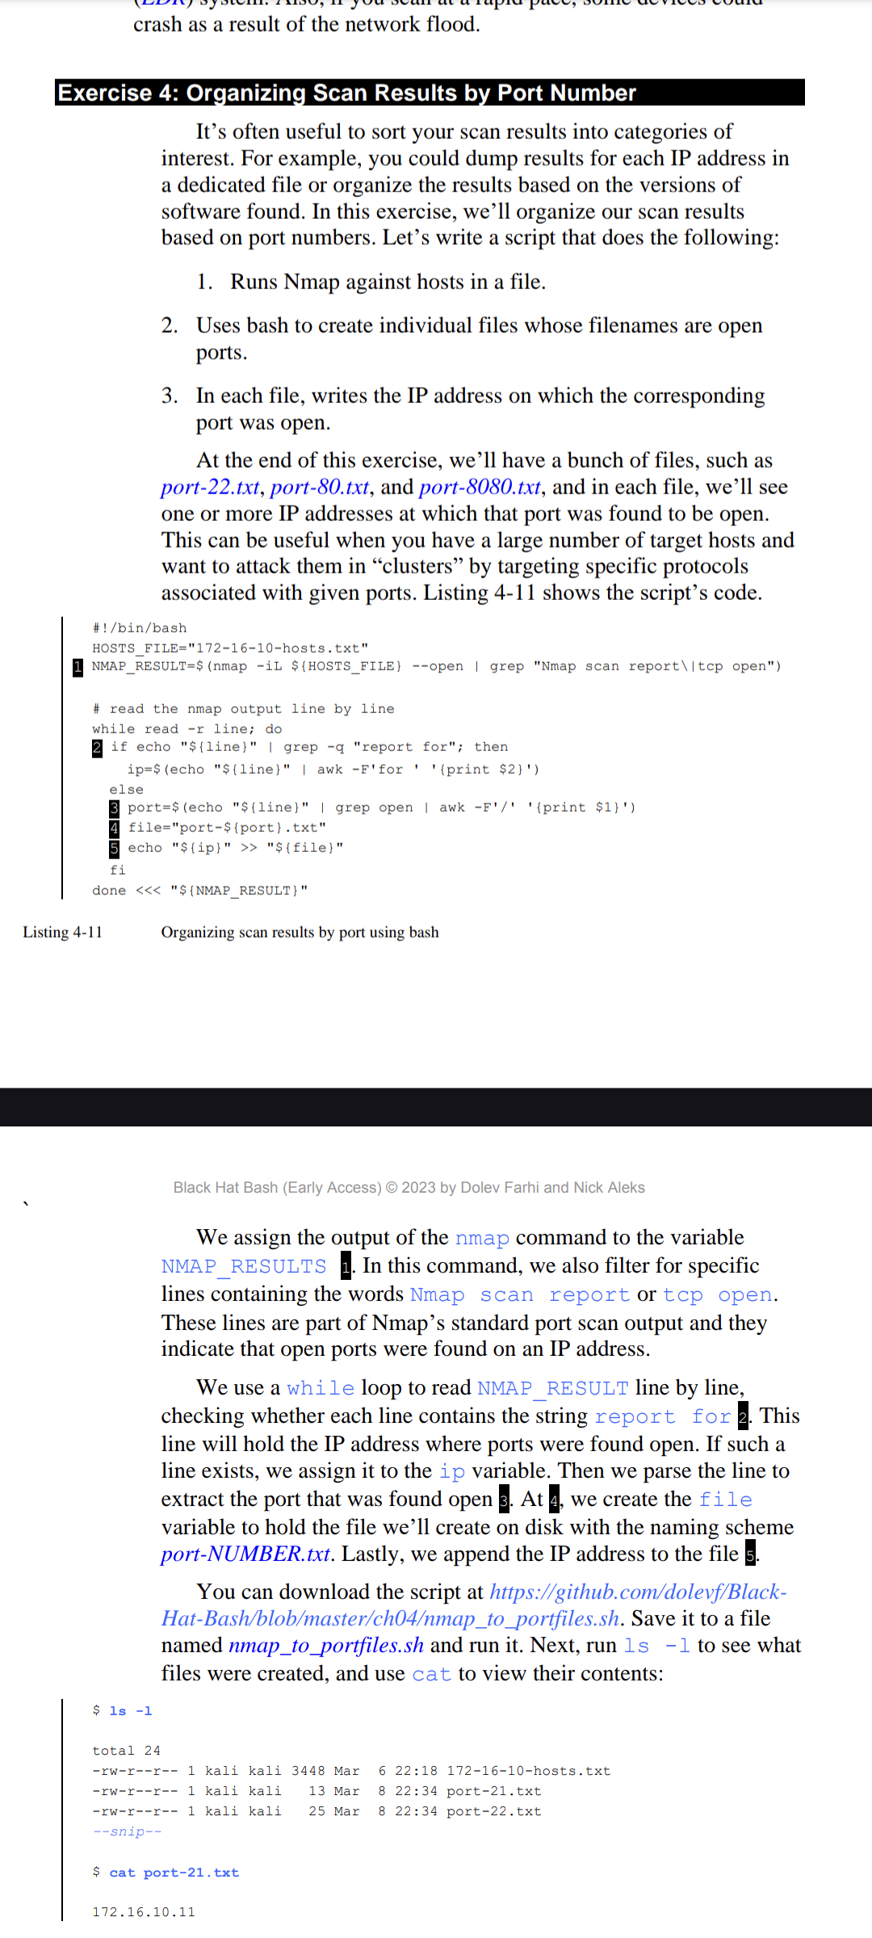

Script Breakdown

* Variables
* HOSTS_FILE="172-16-10-hosts.txt"

This variable specifies the file containing the list of hosts to scan.

* Nmap Scan and Filtering

NMAP_RESULT=$(nmap -iL ${HOSTS_FILE} --open | grep "Nmap scan report\|tcp open")

This command runs an nmap scan on the hosts listed in HOSTS_FILE.

-iL ${HOSTS_FILE} tells nmap to read the list of hosts from HOSTS_FILE.

--open filters the scan to show only open ports.

The output is then filtered using grep to include only lines containing "Nmap scan report" or "tcp open", and the result is stored in the NMAP_RESULT variable.

* Processing Nmap Output

while read -r line; do

This loop reads the NMAP_RESULT variable line by line.

* Extracting IP Addresses and Ports

if echo "${line}" | grep -q "report for"; then

Checks if the current line contains the text "report for", which indicates it is an IP address line.

* Extracting IP Address

ip=$(echo "${line}" | awk -F'for ' '{print $2}')

If the line contains "report for", it extracts the IP address using awk and assigns it to the ip variable.

-F'for ' sets the field delimiter to "for " and {print $2} prints the second field, which is the IP address.

* Extracting Port

else

If the line does not contain "report for", it is assumed to be a port line.

port=$(echo "${line}" | grep open | awk -F'/' '{print $1}')

This extracts the port number using grep and awk.

grep open filters to ensure the line contains "open".

-F'/' sets the field delimiter to "/" and {print $1} prints the first field, which is the port number.

* Writing to File

file="port-${port}.txt"

Constructs the filename based on the port number.

* echo "${ip}" >> "${file}"

Appends the IP address to the file named port-${port}.txt.

* End of Loop

done <<< "${NMAP_RESULT}"

The loop continues to process each line of NMAP_RESULT.

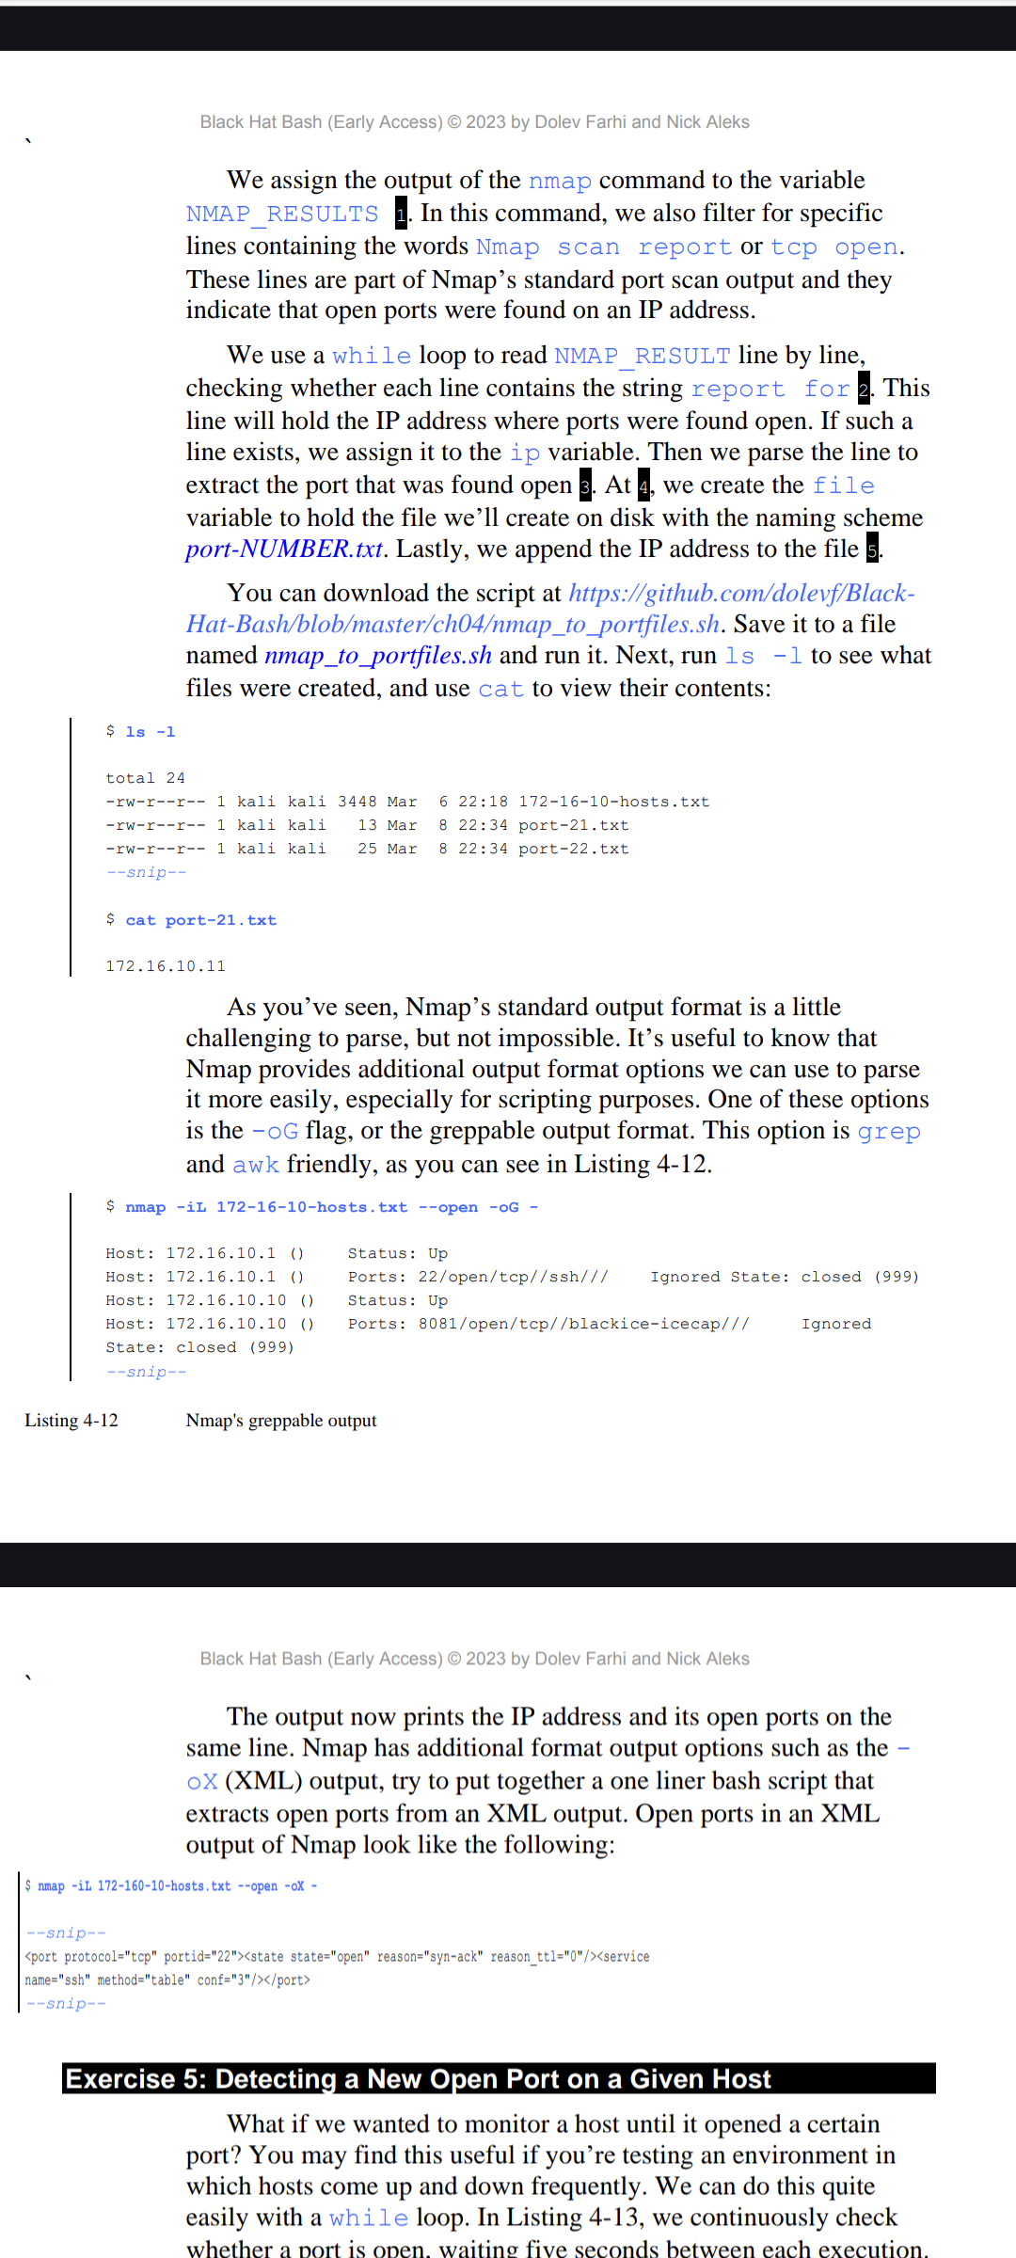

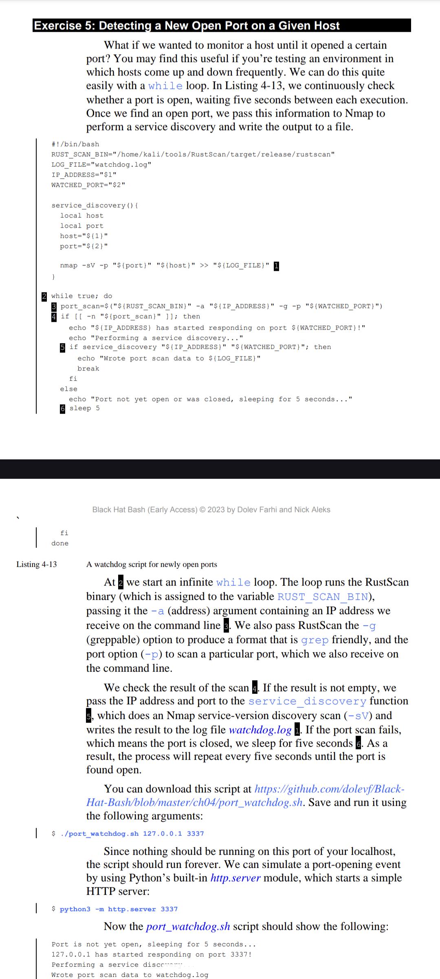

This code is a bash script designed to monitor a specific port on a given IP address and perform service discovery when the port becomes available. Let's break it down line by line:

Lines 1-2:

#!/bin/bash: This line specifies that the script should be run using the bash interpreter.

RUST_SCAN_BIN="/home/kali/tools/RustScan/target/release/rustscan": This line defines a variable RUST_SCAN_BIN that stores the path to a tool called rustscan. This tool is likely used for port scanning.

LOG_FILE="watchdog.log": This line defines a variable LOG_FILE that stores the filename for the log file, named "watchdog.log".

IP_ADDRESS="$1": This line assigns the first argument passed to the script (when it's run) to the variable IP_ADDRESS. This will likely be the IP address you want to monitor.

WATCHED_PORT="$2": This line assigns the second argument passed to the script to the variable WATCHED_PORT. This will likely be the specific port you want to monitor on the target IP.

Line 3:

port_scan=$("${RUST_SCAN_BIN}" -a "${IP_ADDRESS}" -g -p "${WATCHED_PORT}"): This line runs the rustscan tool with the following arguments:

-a "${IP_ADDRESS}": This specifies the IP address to scan.

-g: This flag likely tells rustscan to perform a more thorough scan.

-p "${WATCHED_PORT}": This specifies the port to scan on the target IP.

The output of rustscan is captured in the variable port_scan.

Line 4:

if [[ -n "${port_scan}" ]]; then: This line checks if the port_scan variable contains any data (using double square brackets [[ ]] for a conditional test).

Lines 5-7:

This block executes if the port scan detects something on the target port.

echo "${IP_ADDRESS} has started responding on port ${WATCHED_PORT}!": This line prints a message indicating the target IP is now responding on the watched port.

echo "Performing a service discovery...": This line prints a message indicating the script will perform service discovery.

if service_discovery "${IP_ADDRESS}" "${WATCHED_PORT}"; then: This line calls the service_discovery function (defined later) and passes the IP_ADDRESS and WATCHED_PORT as arguments. If the function execution is successful (exits with code 0), the following code block executes.

echo "Wrote port scan data to ${LOG_FILE}": This line prints a message indicating the port scan data is written to the log file.

break: This statement exits the loop (while loop).

Line 8:

else: This block executes if the port scan detects nothing on the target port.

echo "Port not yet open or was closed, sleeping for 5 seconds...": This line prints a message indicating the port is not yet open or might have been closed. It also states the script will sleep for 5 seconds.

Line 9:

sleep 5: This line pauses the script execution for 5 seconds.

Line 10:

fi: This line closes the else block.

Line 11:

fi: This line closes the if block that checked the port_scan variable.

Line 12:

done: This line marks the end of the while loop. This loop continuously runs the port scan and performs service discovery if the port becomes available, until the break statement is executed inside the successful service discovery block.

Function service_discovery (not shown in the code snippet):

This function likely uses nmap (another port scanning tool) to perform a more detailed scan on the discovered port and identify the service running on that port. It writes the scan data to the watchdog.log file.

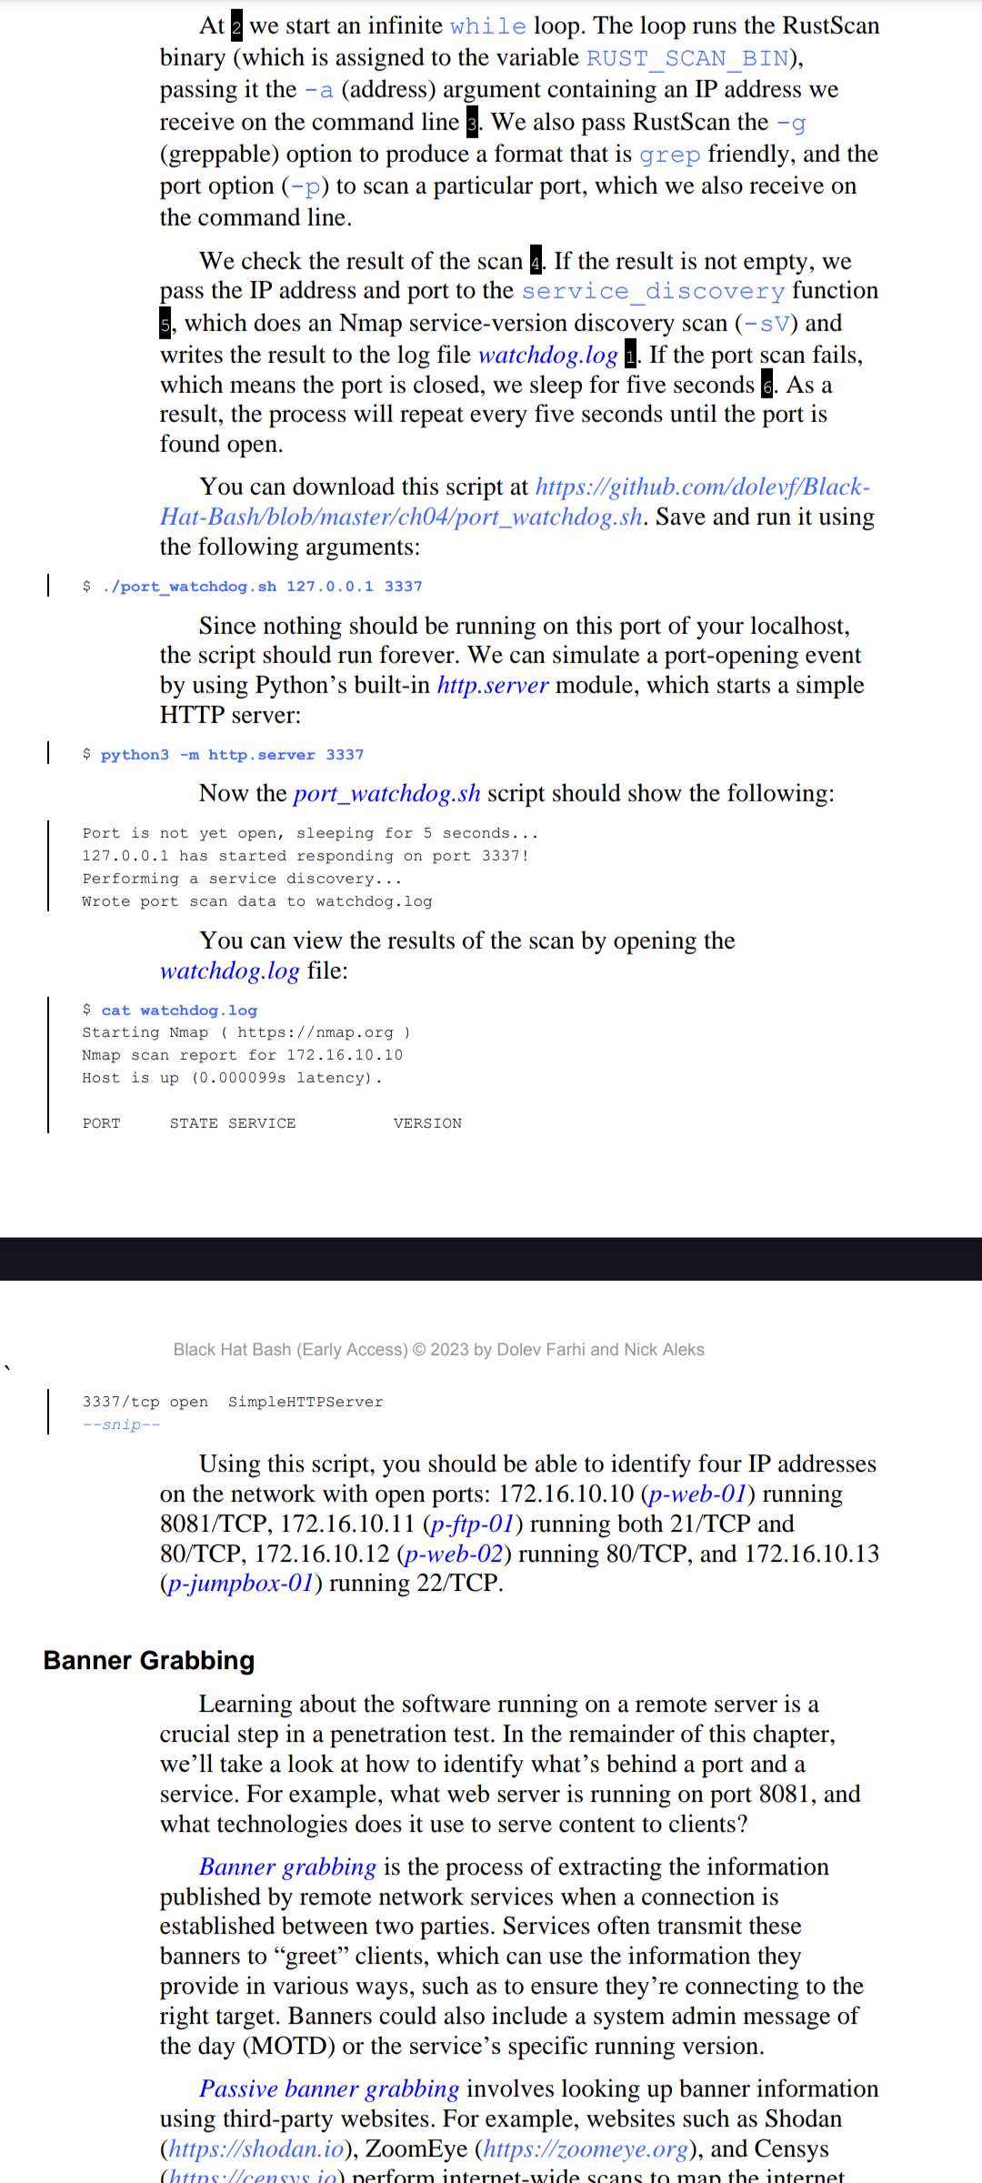

**Passive banner grabbin**g involves looking up banner informationusing third-party websites. For example, websites such as Shodan(https://shodan.io), ZoomEye (<https://zoomeye.org>), and Censys (https://censys.io) perform internet-wide scans to map the internet,grabbing banners, versions, website pages, and ports, then create an inventory using this data. We can use such websites to look up banner information without ever interacting with the target server ourselves.

**Active banner grabbing** is the opposite; it involves establishing a connection to a server and interacting with it directly to receive its banner information. The following network services tend to advertise themselves using banners: web servers, SSH servers, FTP servers,telnet servers, network printers, Internet of Things (IoT) devices, and message queues.

Note : For example :

An Apache server could present itself as a different web server.Some organization’s even have honeypots for banner grabbing threat actors so that they can anlyse the attack patterns and tactics.

1. PERFORMING ACTIVE BANNER GRABBING USING NETCAT

* $ nc 172.16.10.11 -v 21

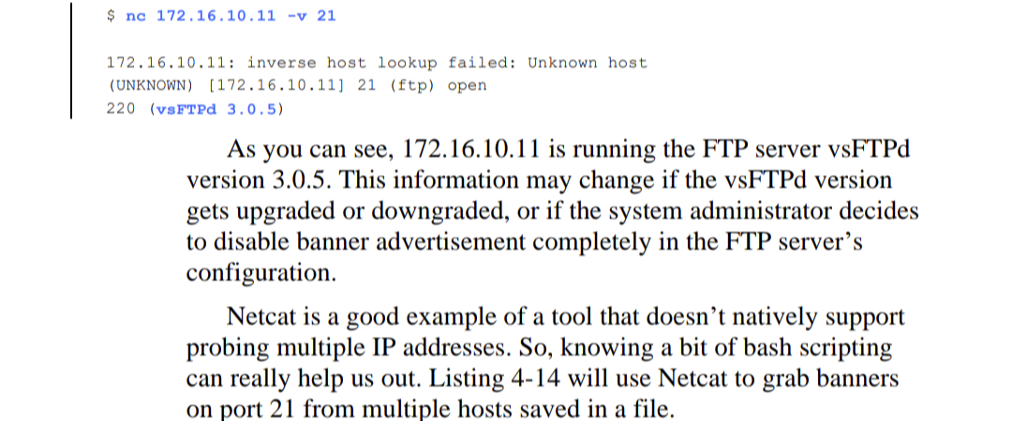

* Now NETCAT usually is only used for a single IP address , here we will use a bit of bash to probe it for multiple IP addresses.

#!/bin/bash

File=”${1}”

Port=”${2}”

if [[ “$#” -ne 2 ]]; then

echo “Usage: ${0} <file> <port>”

exit 1

fi

if [[ ! -f “${File}” ]];then

echo “File: ${FILE} was not found.”

exit 1

fi

if [[ ! “${PORT}” =~ ^[0-9]+$ ]];then

echo “${PORT}” must be a number”

exit 1

fi

while read -r ip; do

echo “Running NETCAT on ${ip} : ${PORT}”

result=$(echo -e “\n”. | nc -v “${ip}” -w 1

“${PORT}” 2> /dev/null)

if [[ -n “${result}” ]];then

echo "==================="

echo "+ IP Address: ${ip}"

echo "+ Banner: ${result}"

echo "==================="

fi

done < "${FILE}”

Explanation for the code above:

$# checks the total number of arguments that are provided with the input. If that is not equal to 2 the code will fail.

Port we check if the input supplied is a number

This script reads a list of IP addresses from a file and attempts to connect to a specified port on each IP address using the netcat (nc) command. Here's a step-by-step explanation of the code:

* File Reading and Looping: while read -r ip; do:

This line starts a loop that reads each line from the specified file (denoted by ${FILE}) and assigns the value to the variable ip.

Echo Command: echo “Running NETCAT on ${ip} : ${PORT}”:

* For each IP address, it prints a message indicating that it's running netcat on that IP address and port (denoted by ${PORT}).
* Netcat Command: results=$(echo -e “\n”. | nc -v “${ip}” -w 1 “${PORT}” 2> /dev/null):
* This line runs netcat to connect to the IP address ${ip} on port ${PORT}.
* echo -e “\n”. sends a newline character to netcat.
* nc -v “${ip}” -w 1 “${PORT}” attempts to connect to the IP address ${ip} on port ${PORT} with a timeout of 1 second (-w 1).
* 2> /dev/null suppresses error messages by redirecting them to /dev/null.
* The output of netcat is stored in the variable results.

If Statement: if [[ -n “${result}” ]]; then:

This checks if the results variable is not empty.

Note: There's a typo here; it should be ${results} instead of ${result}.

Echo Output: If the results variable is not empty, it prints:

echo "===================":

Prints a line of equal signs.

echo "+ IP Address: ${ip}": Prints the IP address.

echo "+ Banner: ${result}": Prints the banner (result of the netcat connection).

echo "===================": Prints another line of equal signs.

Done Loop: done < "${FILE}”:

This indicates the end of the loop, and ${FILE} is the file containing the list of IP addresses.

1. BANNER GRABBING

curl -head 172.16.10.10:8081

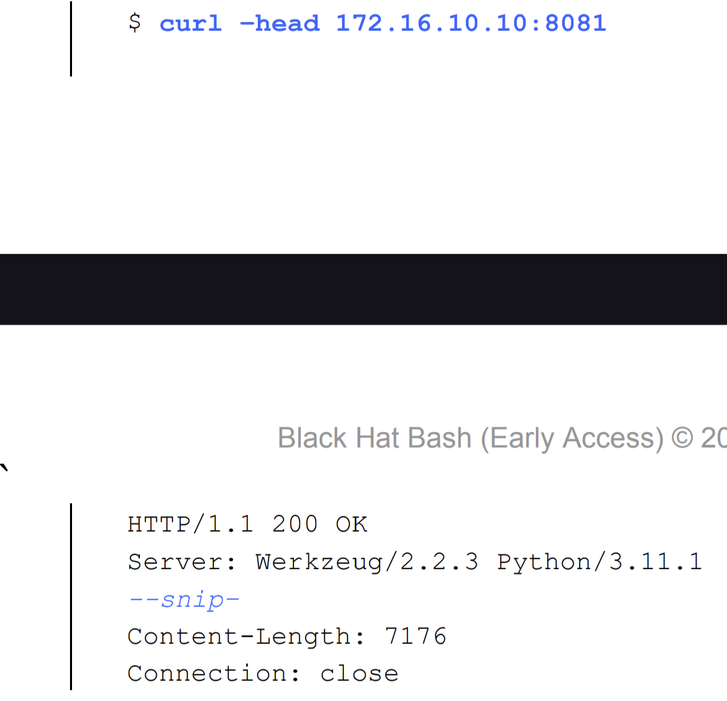

#!/bin/bash

DEFAULT_PORT="80"

read -r -p "Type a target IP address: " ip_address

read -r -p "Type a target port (default: 80): " port

if [[ -z "${ip_address}" ]]; then

echo "You must provide an IP address."

exit 1

fi

if [[ -z "${port}" ]]; then

echo "You did not provide a specific port,

defaulting to ${DEFAULT_PORT}"

port="${DEFAULT_PORT}"

fi

echo "Attempting to grab the Server header of ${ip_address}"..."

result=$(curl -s --head "${ip_address}:${port}" | grep Server | awk -F':' '{print $2}')

echo "Server header for ${ip_address} on port ${port} is: ${result}”

OUTPUT

$ ./curl_banner_grab

Type a target IP address: 172.16.10.10

Type a target port (default: 80): 8081

Attempting to grab the Server header of 172.16.10.10...

Server header for 172.16.10.10 on port 8081 is: Werkzeug/2.2.3 Python/3.11.1

1. NMAP

NMAP is not justa port scanner , it can be turned into a full fledged vulnerability tool. The NMAP scripting engine (NSE) allows penetration testers to write scripts in lua language to extend NMAP capabilities.

Nmap comes pre-installed with some Lua scripts, as you can see here:

$ ls -l /usr/share/nmap/scripts

-rw-r--r-- 1 root root 3901 Oct 6 10:43 acarsd-info.nse

-rw-r--r-- 1 root root 8749 Oct 6 10:43 address-info.nse

-rw-r--r-- 1 root root 3345 Oct 6 10:43 afp-brute.nse

-rw-r--r-- 1 root root 6463 Oct 6 10:43 afp-ls.nse

-rw-r--r-- 1 root root 3345 Oct 6 10:43 afp-brute.nse

-rw-r--r-- 1 root root 6463 Oct 6 10:43 afp-ls.nse

--snip–

The banner.nse script in the /usr/share/nmap/scripts

folder allows you to grab the banners from many hosts simultaneously. The following bash command performs a banner grab and service

discovery (-sV) using this script:

$ nmap -sV --script=banner.nse -iL 172-16-10-hosts.txt

Output:

Nmap scan report for 172.16.10.12

PORT STATE SERVICE VERSION

80/tcp open http Apache httpd 2.4.54 ((Debian))

|_http-server-header: Apache/2.4.54 (Debian)

When the banner-grabbing script finds a banner, the output line containing that banner will begin with a special character sequence (|_). We can filter for this sequence to extract banner information, like so:

$ nmap -sV --script=banner.nse -iL 172-16-10-hosts.txt | grep "|_banner\||http-server-header”

1. DETECTING OPERATING SYSTEM using NMAP

Nmap

Let’s create a bash script that can parse this output and sort it by IP address and operating system.

#!/bin/bash

HOSTS="$*"

if [[ "${EUID}" -ne 0 ]]; then

echo "The Nmap OS detection scan type (-O) requires root privileges."

exit 1

fi

if [[ "$#" -eq 0 ]]; then

echo "You must pass an IP or an IP range"

exit 1

fi

echo "Running an OS Detection Scan against ${HOSTS}..."

nmap_scan=$(sudo nmap -O ${HOSTS} -oG -)

while read -r line; do

ip=$(echo "${line}" | awk '{print $2}')

os=$(echo "${line}" | grep OS | awk -F'OS: ' '{print $2}' | sed 's/Seq.*//g')

if [[ -n "${ip}" ]] && [[ -n "${os}" ]]; then

echo "IP: ${ip} OS: ${os}"

fi

done <<< "${nmap_scan}”

This code performs a network scan and extracts information about the discovered hosts. Here's a breakdown of what each part does:

1. Scanning:

nmap_scan=$(sudo nmap -O ${HOSTS} -oG -): This line runs the nmap command with several options:

sudo: This grants temporary administrative privileges to run nmap.

-O: This flag enables operating system detection for the target hosts.

${HOSTS}: This is a variable likely containing a list of IP addresses or hostnames to scan (replace ${HOSTS} with the actual variable name).

-oG -: This specifies the output format as grepable (-G) and sends it to standard output (-).

2. Processing Output:

while read -r line; do: This loop iterates over each line of the nmap_scan command output.

read -r line: Reads a line from the output and assigns it to the variable line.

3. Extracting IP Address:

ip=$(echo "${line}" | awk '{print $2}'): This extracts the second field (IP address) from the current line ($line) using awk.

echo "${line}" | awk '{print $2}': Pipes the line to awk which prints the second column ($2).

4. Extracting Operating System:

os=$(echo "${line}" | grep OS | awk -F'OS: ' '{print $2}' | sed 's/Seq.*//g'): This extracts the operating system information from the line.

echo "${line}" | grep OS: Pipes the line to grep to filter lines containing "OS".

awk -F'OS: ' '{print $2}': Further filters the output using awk to print only the text after "OS: " (second field separated by ": ").

sed 's/Seq.*//g': Removes any text following "Seq" (common in Nmap output) using sed.

5. Printing Results:

if [[ -n "${ip}" ]] && [[ -n "${os}" ]]; then: This checks if both ip and os variables have values (not empty).

[[ -n "${ip}" ]]: Checks if ip is not empty.

[[ -n "${os}" ]]: Checks if os is not empty.

echo "IP: ${ip} OS: ${os}": If both have values, this line prints the extracted IP address and operating system.

1. ANALYSIBG WEBSITES WITH WAPPALYZER

It is a database to check softwares running on remote targets, including web frameworks ,web servers, databases ,OS, content management,systems ,font,programming languages and UI frameworks.

How to run it :

wappalyzer <http://172.16.10.10:8081>

Output :

"urls":{"http://172.16.10.10:8081/":{"status":200}},"technologies":[{"slug":"python","name":"Python","description":"Python is an interpreted and general-purpose programming language.",

"confidence":100,"version":"3.11.1","icon":"Python.png”

Wappalyzer output is in JSON format that is composed of keys and values. To parse it we will use a tool like jq to extract information from the JSON format.

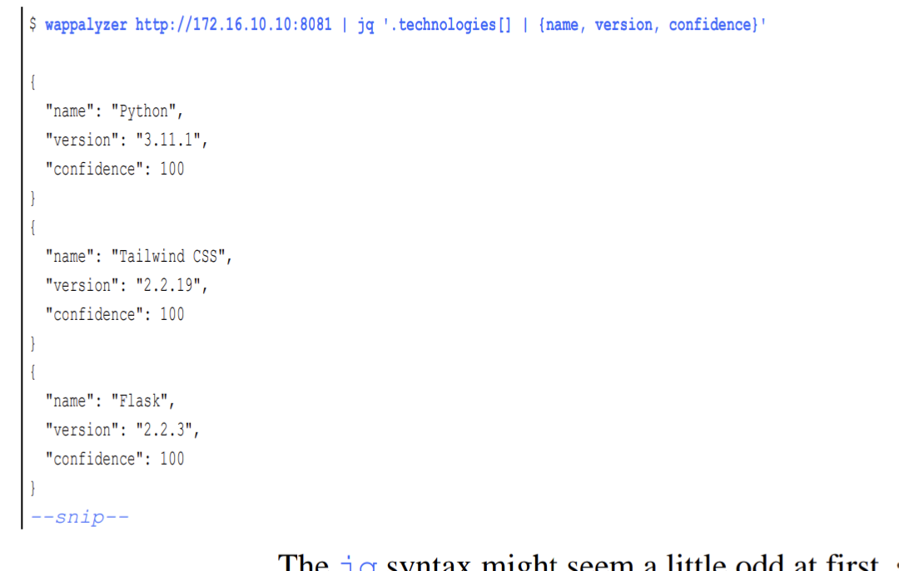

HAVE NOT DONE CHAPTER 5.